GRIDVISION
Football Analysis and Strategy Building
ACADEMIC PROJECT REPORT
System Design Implementation and Testing
Submitted by
Paavani Maheshwari
Ria Nirkhe
NSOMASA
BSc Applied Mathematical Computing
Academic Year 2026–27

Project Overview

Purpose
GridVision combines football information with an interactive space for planning tactics. Users can search player records, compare squads, inspect suggested playing styles, arrange a lineup, and browse fixtures. Saved strategies and personal events support work that continues across visits.

Application structure
The website uses Next.js and React for its interface and server workflows. TypeScript defines the data structures, while Drizzle ORM supports PostgreSQL storage. The design diagrams explain how pages, server actions, data stores, and external services are connected.
The Strategy Builder allows players to be moved or swapped on a pitch. Users request feedback through Evaluate Strategy after making changes. A saved snapshot records the formation, player assignments, coordinates, notes, and available feedback.

Results of the evaluation
Browser testing confirmed public navigation, player search, sampled profile pages, competition filtering, and squad-style explanations. Local saved-strategy tests preserved pitch coordinates and enforced ownership. The TypeScript check completed without diagnostics. Protected production workflows require further testing with a designated account.

Report organisation
The report follows the development of the application from requirements to design and implementation. Frontend, backend, database, and sequence diagrams explain the system structure. The testing chapter records expected behaviour, actual observations, screenshots, execution logs, and remaining checks.

Design Considerations

Connecting information with decisions
Player records and squad ratings provide background for choosing a lineup. The tactical board then gives users a way to try formations and rearrange players. Keeping these tasks in one application helps users move from browsing football information to planning a strategy.

User control over evaluation
Dragging and swapping change the lineup without requesting a new analysis. Evaluate Strategy makes the next step explicit. Initial XI generation also requests a starting plan. The current feedback follows rules based on player attributes and role labels; the implementation chapter explains what those rules can assess.

Saving personal work
Saved strategies retain player assignments and pitch coordinates, so a formation can be revisited. Server operations use the account identity to identify the owner. Local tests confirmed the exercised ownership checks. Production persistence still needs to be tested across sessions and deployments.

Testing at different levels
The evaluation combines source inspection, browser observations, and isolated runtime checks. Each method answers a different question. Source inspection explains the code path, browser tests show visible behaviour, and runtime checks verify selected calculations or storage operations.

Calendar update
The project team confirmed that the calendar issue was resolved on 23 October 2026. The testing chapter records this update alongside the original results. Independent regression testing remains pending.

Abstract
GridVision is a football analysis and strategy-building website. It brings player exploration, team comparison, tactical arrangement, saved strategies, and fixture planning into one application. The system uses Next.js, React, TypeScript, Tailwind CSS, server actions, and PostgreSQL-compatible data stores. Career records and competition datasets provide the football information used across the interface.
The project evaluation combined source inspection, public browser testing, TypeScript checking, and isolated tests of storage and analytical functions. Screenshots and selected execution logs support the findings. Protected workflows and tests requiring additional accounts, services, or device settings were recorded as blocked or not run.
Of 42 executed test cases, 32 met their acceptance criteria. The full register contains 63 cases, including 17 blocked cases and four not run. Three original calendar failures relate to the issue subsequently reported resolved by the team. Their original results are retained pending independent regression testing; unrelated results are unchanged.
The application demonstrates working public exploration features and selected storage and calculation functions. Tactical feedback currently uses deterministic rules and a response template. Further work should validate protected production workflows, confirm durable storage, and address the remaining API and data-presentation findings.

Contents
1 Introduction 8
2 Functional Requirements 13
3 Overall System Architecture 18
4 Dashboard and Application Shell 28
5 Testing Methodology and Environment 40
6 Deployment Architecture and Release Requirements 55

Chapter guide
Introduction and project scope 8–12
Requirements roles technologies and datasets 13–17
Architecture data flows schema and sequences 18–27
Feature implementation and production screenshots 28–39
Test plan cases logs evidence and defects 40–54
Deployment security limitations and conclusion 55–59
The following chapters cover the project requirements, system design, implementation, testing, and deployment. Figures and tables are listed on the next two pages.

List of Figures
The diagrams describe the inspected application. Screenshots record the browser states observed during testing; historical evidence is labelled separately.
Figure 1 Overall system architecture 18
Figure 2 Frontend navigation and component structure 19
Figure 3 Backend actions routes and storage 20
Figure 4 User roles and application use cases 21
Figure 5 Context level data flow 22
Figure 6 Level one data flow 23
Figure 7 Database entities and logical relationships 24
Figure 8 Signup verification and login sequence 25
Figure 9 Lineup generation and evaluation sequence 26
Figure 10 Saved strategy operations 27
Figure 11 Dashboard in World Cup mode 28
Figure 12 Player Explorer with search and filters 29
Figure 13 Sample player profile 30
Figure 14 Tactical style suggestions for France 32
Figure 15 Dashboard in Premier League mode 33
Figure 16 Strategy Builder access screen 34
Figure 17 Calendar retrieval synchronisation and event flow 37
Figure 18 Serie A calendar filter at the original assessment 53
Figure 19 Historical email delivery configuration message 53
Figure 20 Deployment architecture 55

List of Tables and Evidence Conventions
Table 1 Objectives and Success Measures 10
Table 2 Functional Requirements 13
Table 3 Nonfunctional Requirements 14
Table 4 User Roles and Permissions 15
Table 5 Technology Stack and Dependencies 16
Table 6 Data and External Service Inventory 17
Table 7 Player Photographs and Presentation 31
Table 8 Ratings Predictions and Analytical Methods 33
Table 9 Explicit Evaluation and Strategy Assistant 35
Table 10 Saved Strategy Implementation 36
Table 11 Personal Events Sharing and Refresh 38
Table 12 Authentication Storage and Error Handling 39
Table 13 Testing Methodology and Environment 40
Table 14 Requirements Coverage and Status Accounting 41
Table 15 Test cases B01 to B07 42
Table 16 Test cases B08 to B14 43
Table 17 Test cases B15 to B21 44
Table 18 Test cases B22 to A04 45
Table 19 Test cases A05 to A10 46
Table 20 Test cases A11 to A16 47
Table 21 Test cases A17 to C03 48
Table 22 Test cases C04 to C09 49
Table 23 Test cases C10 to C15 50
Table 24 Test cases C16 to C20 51
Table 25 Defect Register and Readiness Assessment 54
Table 26 Configuration and Maintenance 56
Table 27 Security Controls and Gaps 57
Table 28 Limitations and Practical Improvement Plan 58
Table 29 Conclusion and Demonstration Checklist 59
Evidence labels
PROD identifies public browser observations; LOCAL identifies isolated execution; HIST identifies historical screenshots. Source inspection is identified separately from an executed functional test.
Assessment version
Source package: GridVision-complete-project.zip. Application version: 0.1.0. SHA-256: 3c59d579167d83ed6b820816deb3436d82d5b9ac87a52291fc6fece4a26c0c6b. The production deployment did not expose a commit identifier.
Status definitions
Pass: acceptance criterion observed. Fail: criterion not met at the original test. Blocked: prerequisite unavailable. Not Run: execution deferred. TEAM1 identifies the calendar resolution reported on 23 October 2026; regression is pending.

1 Introduction
Football information is often spread across player databases, squad rankings, tactical boards, and fixture calendars. GridVision brings these activities into one browser application. Its main purpose is to help users explore football data and use that information while arranging a team.
The interface uses a dashboard with persistent navigation. Visitors can browse player profiles, inspect squad ratings, and view fixtures. The Strategy Builder requires a verified account. Its intended workflow is to select a club or Dream Team, choose a formation, arrange players on the pitch, and request feedback.
The project applies frontend development, server-side programming, data handling, and access control to a single application. It also provides a practical setting for testing the connection between interface behaviour and backend operations.
The implemented scope is football exploration and tactical planning. Video analysis, facial recognition, player tracking, and automatic video annotation are outside the completed feature set. They are discussed only as possible future developments.
The next chapters describe the requirements, explain the application structure, and document the principal features. The testing chapter then compares expected behaviour with the results obtained from the public site and the supplied source package.

1.1 Problem Statement
The problem addressed by GridVision is the separation between football information and tactical planning. A user may find player statistics on one page but need another tool to arrange a lineup. The project aims to provide both activities within a consistent interface.
Personal work also needs continuity. A user should be able to save a tactical arrangement and return to it later. Fixture planning adds another requirement: private notes and shared events need clear ownership and editing permissions.
Project feedback identified practical concerns in player presentation, dropdown labels, career information, fixture availability, and account setup. These informed the requirements for consistent labels, understandable data, and reliable service configuration.
The central design question is how to connect player exploration, tactical arrangement, and personal planning without making the interface difficult to use. The evaluation considers both visible features and the server operations that support them.
Data quality forms part of this problem. Squad membership, career status, and match schedules can change over time. Dataset dates and source information are therefore needed to help users interpret what the website displays.

1.2 Objectives and Success Measures
The primary objective is to support football strategy exploration through a consistent interface. The user should reach the relevant screen, understand the selected competition, identify a player, and build an eligible lineup without unnecessary automatic analysis requests.
The supporting objectives are measurable. Search should return matching names, clubs, or nationalities and show a clear empty state. Competition context should use national-team terminology for World Cup data and club terminology for domestic leagues. Strategy changes should remain local until an explicit evaluation action, except for the initial plan request during XI generation that currently exists in code.
Saved strategies should retain assignments, formation, coordinates, notes, and the associated feedback snapshot. Their server operations should use the authenticated user’s identifier. Calendar events should distinguish public fixtures, private notes, and explicitly shared records. Signup should produce a verifiable link and verified login should create a valid session.
Success must be checked at the relevant level. A storage test can verify that coordinates are retained, while a browser test must confirm that the saved lineup reopens correctly. Production durability requires a separate check against the deployed database.
The project should also explain the meaning of its recommendations. Deterministic style scores and rating-derived match probabilities are acceptable prototype methods when labelled accurately. A model-backed agent, learned tactical intelligence, and calibrated forecast accuracy require additional implementation and evaluation.
Table 1 Objectives and Success Measures
Objective | Acceptance evidence
Explore players | Correct search filter sort and profile results
Arrange tactics | Eligible XI with stable pitch interactions
Evaluate explicitly | No move-triggered request; submitted lineup feedback
Persist personal work | Reopen across sessions with owner isolation
Deliver verification | Provider event plus recipient receipt and valid link

1.3 Scope and Boundaries
The inspected scope includes the dashboard, Player Explorer and profiles, Clubs & Leagues overview, interactive strategy screen, saved-strategy actions, calendar views and event actions, and custom email/password authentication. Four competition selectors exist: FIFA World Cup, Premier League, La Liga, and Serie A. The selector identifiers are called seasons in the code, although they are competition categories rather than chronological seasons.
The Player Explorer uses a separate career dataset containing 1,724 records. Competition ratings contain 1,248 World Cup players, 660 Premier League players, 610 La Liga players, and 629 Serie A players. These counts represent records in distinct snapshots; they should not be added as a total of unique footballers.
Public tests were confined to normal signed-out browsing. The report did not create production accounts, send verification messages, alter shared fixtures, delete user records, or redeploy the application. Local saved-strategy test records were disposable and confined to an isolated working directory.
External services are described only where code references or provider documentation support them. PostgreSQL deployment settings, Resend domain verification, inbox receipt, and the intended Django Elo engine were not available for inspection as live administration resources.
The supplied ZIP was sufficient to inspect the application without GitHub access. The current strategy request path uses local analytical functions. An external sports-analysis engine was not demonstrated in that path.

1.4 Existing Approaches and Project Rationale
Football tools serve different purposes. Statistical databases support player research, rating systems support comparisons, tactical boards support positioning, and calendars support scheduling. GridVision combines selected functions from each category.
A tactical board allows users to compare formations and reason about player roles. Rules-based feedback can provide a starting point for that discussion. Detailed assessment of space, defensive cover, or overloads would require the evaluation to receive pitch coordinates and account for nearby players.
The club-style module uses weighted attribute scores and competition benchmarks to suggest playing styles. Its panel explains that the suggestions are based on squad ratings. This makes the reasoning easier to inspect, although it does not establish how a club performs in actual matches.
The application scope prioritises football analysis and tactical planning. The removal of fan-majority displays and market-value presentation supports this focus by reducing unrelated interface elements. Monetary fields remain in legacy datasets and derivation scripts; these retained data properties are distinguished from the currently visible feature set.
The design and test records provide a starting point for further development. They explain how the application works, identify the behaviour observed during assessment, and show where additional testing or implementation is needed.

2 Functional Requirements
The functional requirements cover navigation, player discovery, squad comparison, tactical planning, personal records, and account access. Table 2 links each requirement to its implementation location. The testing chapter assesses these requirements through specific cases.
Navigation must expose public exploration routes and direct unauthenticated users to sign in for strategy access. Player discovery must support text search, status selection, position and club filters, and meaningful sorting. A league-aware player view was requested earlier, but the current career explorer does not read the global competition context.
The strategy workspace must select eligible players, build formations, support movement or swaps, request feedback explicitly, and preserve named snapshots. The calendar must support competition and team filters, month and week navigation, upcoming entries, personal events, and explicit sharing permissions.
Authentication must validate input, hash credentials, send a single-use verification link, reject unverified login, allow resend with a cooldown, and clear the session on logout. Actual delivery must be assessed beyond the provider’s initial API response.
Table 2 Functional Requirements
ID | Requirement | Implementation location
R01 | Public navigation and context | AppFrame SeasonProvider
R02 | Player search filters profiles | app/players and lib/players
R03 | Team comparisons and style suggestions | overview style-analysis prediction
R04 | Interactive lineup and explicit evaluation | strategy page and strategy-pitch
R05 | Save reopen update duplicate delete | strategy actions and store
R06 | Fixtures notes sharing and sync | calendar actions components store
R07 | Verified-account authentication | auth actions session email-service

2.1 Nonfunctional Requirements
The main quality requirements are readability, predictable state changes, reliable storage, and controlled access. Data labels should help users distinguish a historical record from a calculated rating or an external response.
Responsive design should keep the pitch, player lists, modal dialogs, calendar cells, and chat usable at common desktop, tablet, and mobile widths. The code includes responsive Tailwind classes and a mobile navigation treatment. The available browser session supplied a desktop viewport; smaller breakpoints were not executed and remain blocked tests.
Operational reliability requires durable database storage in production. Silent fallback to local files can hide database errors and lead to inconsistent records across server instances. The report therefore treats local fallback as a development aid rather than proof of deployable persistence.
Security requirements include a strong signing secret, private server-side email credentials, role and ownership checks, controlled verification token lifetime, and safe logging. The inspected code implements several controls but logs complete verification URLs and contains a default signing-secret fallback. Their actual production configuration is not visible.
Maintainability requires reproducible dependencies, schema setup, dataset provenance, test commands, and a clean distinction between current and legacy components. The package has development, build, and start scripts, but no standard test script. Two supplied test utilities require additional setup.
Table 3 Nonfunctional Requirements
Quality | Required outcome | Assessment concern
Usability | Readable consistent labels | Raw ALL and goals labels remain
Reliability | Durable cross-session storage | Production DB not verified
Security | Verified user and owner enforcement | Strategy route lacks session guard
Reproducibility | Known source and dependency versions | Cached dependency reuse disclosed
Transparency | Accurate method and freshness labels | Historical and derived data mixed

2.2 User Roles and Permissions
GridVision has two main account states: public visitor and verified account holder. Event sharing adds view or edit permission for a particular record. The inspected schema does not define a separate administrator account role.
A public visitor can browse the dashboard, player pages, team overview, and fixture calendar. The Strategy Builder interface shows an Email Verification Required gate. A verified account can access personal functionality once a valid session exists. Server-side saved-strategy actions derive the owner from the session instead of trusting a caller-supplied owner identifier.
For events, the owner can manage the record and its sharing list. A recipient may receive view or edit permission. Permission must be checked in the data layer even if the interface hides editing controls. The local and database implementations need separate tests because their returned metadata and error paths differ.
Deployment maintenance takes place outside the website. It includes hosting configuration, environment variables, DNS, and database setup. These activities are shown as operational responsibilities rather than application permissions.
The interface and API must enforce the same boundary. Local invocation of POST /api/strategy returned a plan without authentication, demonstrating a source-level gap relative to the protected-screen claim. This does not establish that private stored data can be read through that route; the observed route produces rules-based feedback from supplied input.
Table 4 User Roles and Permissions
Actor | Allowed purpose | Required boundary
Visitor | Browse public data | No personal records
Verified user | Build and save own strategy | Session and ownership
Event owner | Manage event and shares | Owner-only deletion and sharing
Shared viewer | Read a selected event | No edit permission
Shared editor | Edit selected event | Explicit edit grant
Maintainer | Operate deployment | External service permissions

2.3 Technology Stack and Dependencies
The application is a Next.js App Router project with React client components and server actions. package.json declares Next.js 16.3.3, React and React DOM on major version 19, and TypeScript 5.7.3. The build script uses next build --webpack. Tailwind CSS and its PostCSS integration define the styling pipeline.
Base UI components and project-local UI wrappers provide controls and dialogs. Lucide React supplies icons. Recharts provides the overview bar and scatter charts. SWR retrieves session and calendar data with client-side revalidation. Drizzle ORM and pg implement PostgreSQL access. Node crypto implements password hashing, random verification tokens, and signed sessions.
The dependency list includes the ai package. In the inspected strategy path, however, local functions generate the tactical plan and browser code constructs chat responses. This implementation does not demonstrate a model API call.
The dependency check reused an existing cached node_modules tree containing Next.js 16.3.3. It did not perform a fresh pnpm lockfile installation. TypeScript and isolated runtime results therefore describe this available dependency environment. A clean installation in a release pipeline remains necessary.
No Python or Django backend source was included as the active web backend in this ZIP. The Elo route contains a loopback HTTP reference to a Django endpoint; that reference is documented as an external dependency with no verified deployment.
Table 5 Technology Stack and Dependencies
Layer | Declared technology | Use
Web framework | Next.js 16.3.3 React 19 | Pages actions routes
Language | TypeScript 5.7.3 | Typed frontend and backend
UI | Tailwind Base UI Lucide | Layout controls icons
Charts and fetching | Recharts 3.8.0 SWR 2.5.1 | Visualisation revalidation
Persistence | Drizzle 0.45.2 pg 8.23.1 | PostgreSQL stores
Email | Resend HTTP API | Verification messages

2.4 Data and External Service Inventory
The application has two major football data families. lib/players/players.json supplies career profiles for Player Explorer. lib/fifa JSON files supply competition squads and player attributes for the dashboard, style analysis, and strategy building. Legacy FPL snapshots are also bundled, but the active getSeason mapping selects the FIFA files.
The career module attributes its one-off aggregation to salimt/football-datasets and a Transfermarkt datalake. Domestic generation code points to a FIFA CSV in tkarim45/Beginner-Data-Science-Projects. The World Cup generator references mominullptr/FIFA-World-Cup-2026-Dataset, then derives FIFA-like attributes from values, caps, average ratings, and deterministic adjustments. These are source-code provenance statements, not a fresh licence or factual audit.
The original inspected calendar seed contains 48 fixtures across four competitions: 21 World Cup, 11 Premier League, eight La Liga, and eight Serie A. Its dates describe the assessment snapshot. The team reports that the subsequent calendar issue has been resolved; this historical inventory does not describe the contents of an independently inspected updated release.
Resend is contacted server-side for verification delivery. FPL endpoints are contacted during explicit fixture sync. The Elo API attempts a loopback Django request. Player images are external URLs, principally associated with Transfermarkt portraits. A licence ledger and reliable image-update dates were not supplied.
Public provider documentation was consulted for the Resend test-domain restriction and Vercel function filesystem behaviour. Dataset factual claims were not expanded into verified current football facts.
Table 6 Data and External Service Inventory
Data family | Records | Primary consumer
Career players | 1,724 | Explorer and identity matching
World Cup ratings | 1,248 players / 48 teams | Dashboard strategy style
Premier League ratings | 660 players / 20 teams | Dashboard strategy style
La Liga ratings | 610 players / 20 teams | Dashboard strategy style
Serie A ratings | 629 players / 20 teams | Dashboard strategy style
Fixture seed | 48 fixtures | Calendar fallback

3 Overall System Architecture
GridVision uses a single Next.js application for the interface and server workflows. React pages render the screens. Server actions manage accounts, saved strategies, and events, while route handlers provide the strategy and Elo endpoints.
Bundled JSON files supply football data to the analytical modules. Personal records pass through store modules. These use PostgreSQL when configured and otherwise attempt local JSON files under .data. The local fallback is useful for development but needs separate consideration on a serverless host.
Resend and FPL are external integrations. The inspected strategy path does not call an external model service. Figure 1 shows the application relationships; availability of the database and external services depends on deployment configuration.
Authentication, ownership, and input checks need to be enforced by the server. A protected screen alone does not enforce access to its API. The missing strategy-route session check is recorded in the test results.
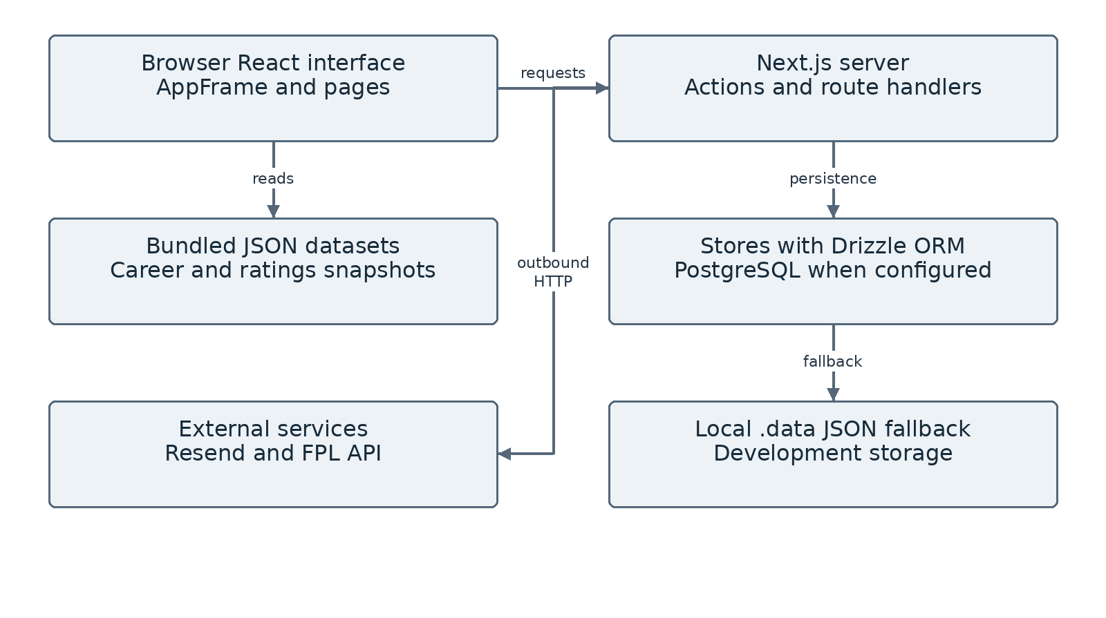
Figure 1 Overall system architecture

3.1 Frontend Navigation and Components
RootLayout applies fonts, global styles, metadata, the AppFrame shell, and production analytics. AppFrame wraps pages in SeasonProvider and supplies desktop and mobile navigation. The global selection contains four competition slugs and is held in React state rather than demonstrated durable storage.
The dashboard uses matchup and stat components. Overview combines charts, team aggregates, and ClubStylePanel. Player Explorer uses its independent career dataset and PlayerAvatar. Strategy Builder contains a large stateful page with pitch and modal components. Calendar splits its presentation into header, filters, month, week, upcoming, and event/detail dialogs.
The separation supports reuse but does not guarantee consistent terminology. The overview heading responds to national-team mode, while its sidebar label remains Clubs & Leagues. Player Explorer does not automatically become a Premier League-only list when the global competition selector changes.
The frontend diagram groups the main pages and components. Account routes provide entry points for signup and login, while the Strategy Builder checks the account state within the page.
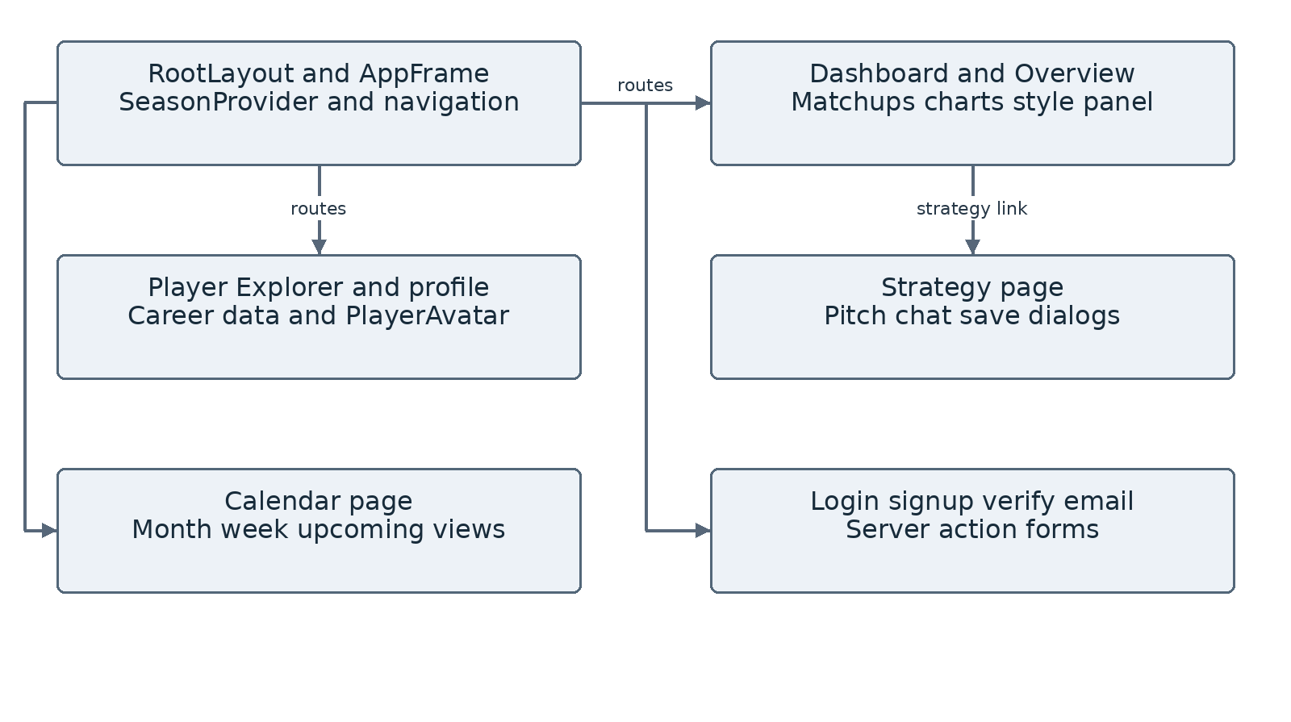
Figure 2 Frontend navigation and component structure

3.2 Backend Services and API Boundaries
Three groups of server actions handle accounts, calendar records, and saved strategies. Client components invoke these through Next.js. Two route handlers are exposed explicitly: GET /api/elo and POST /api/strategy.
Authentication actions validate form data, manage users and tokens, send email, and set or clear a cookie. Strategy actions obtain the session and call owner-scoped store functions. Calendar actions combine public fixture retrieval with permitted personal events and provide event mutations and explicit sync.
The strategy route accepts generate and evaluate modes. The separate GeminiQuickAsk component sends ask mode, which the route rejects with Invalid request. The endpoint parses JSON before entering its try block; malformed JSON therefore escapes the route’s custom error response in isolated execution.
The Elo route attempts http://127.0.0.1:8000/api/gridvision-elo/ with a three-second timeout and returns a fallback status when unreachable. This loopback address is not a remote backend deployment.
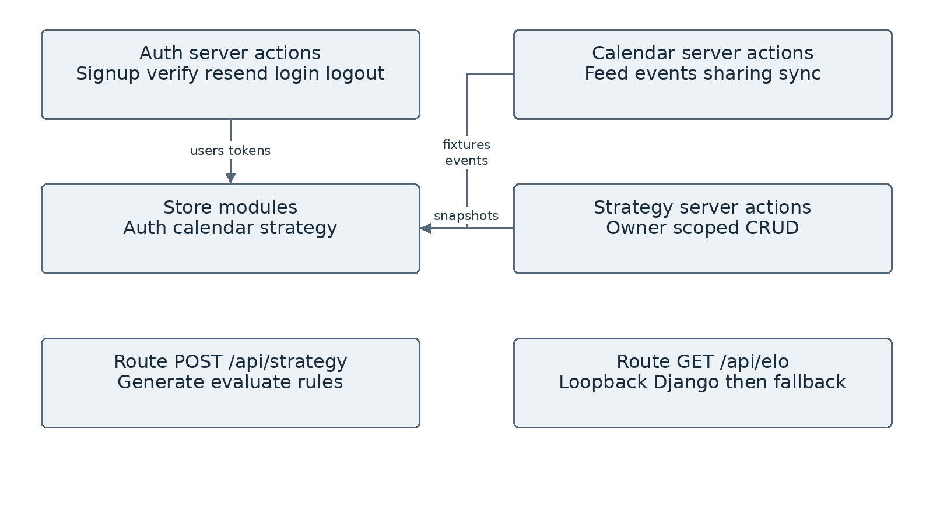
Figure 3 Backend actions routes and storage

3.3 Use Cases and User Roles
The use-case model centres on public exploration and personal planning. Visitors browse players, compare squads, and inspect fixtures. Verified users prepare and save tactical arrangements. Event owners share notes with selected recipients, who may have view or edit capability.
A deployment maintainer is included in the use-case diagram to show responsibility for configuration and hosting. This is an operational responsibility, not an account type defined in the application.
The main planning use case begins with selecting a competition and squad, selecting players and a formation, generating an XI, adjusting the pitch, and requesting evaluation. Saved snapshots provide continuity. The calendar use case combines official fixture entries with personal records and permissions.
The browser check confirmed that the strategy screen blocks signed-out access. Local route testing found that the feedback handler lacks the same check. Saved-strategy ownership checks passed in the isolated store tests.
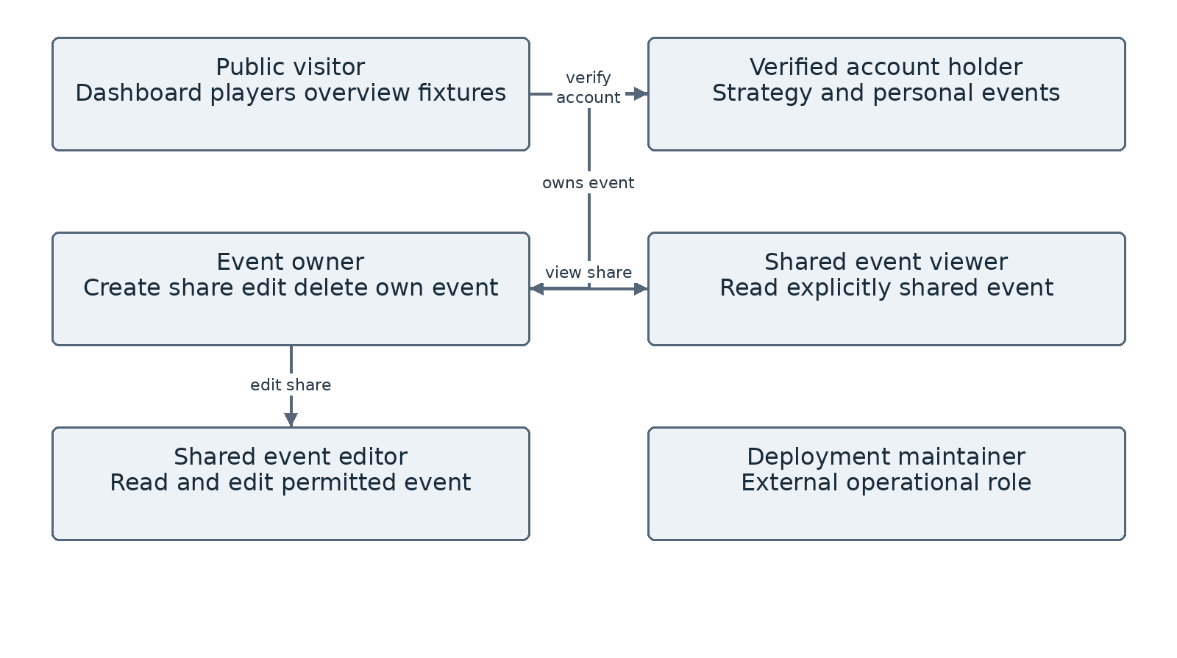
Figure 4 User roles and application use cases

3.4 Context Level Data Flow
Users provide selections, questions, and event details. The application returns pages, calculated ratings, and tactical feedback. Football data enters through bundled files and external requests, while personal records are handled by the storage modules.
The email provider and recipient inbox are separate external actors. End-to-end delivery is validated through a designated inbox test; a provider response alone establishes only the sending-stage outcome.
Source labels stored with a profile or fixture are displayed in the interface. They describe the project data pipeline. To establish freshness, the application should also retain the date on which the information was retrieved or checked.
The data-flow diagram covers the implemented football and planning functions. Video recognition, live tracking, and fan voting are outside this flow.
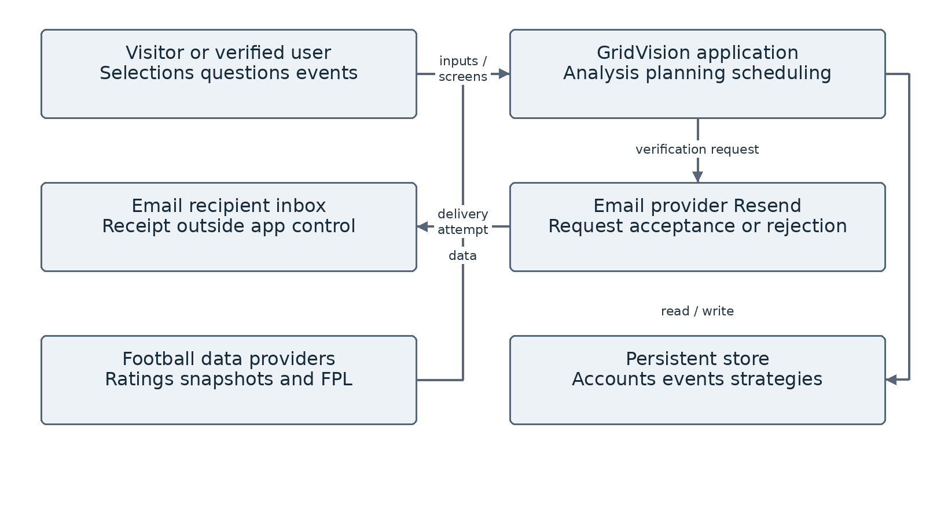
Figure 5 Context level data flow

3.5 Level One Data Flow
The Level 1 diagram separates browsing, authentication, strategy construction, saving, calendar management, and fixture synchronisation. Browsing can use bundled files. Personal records additionally depend on the current session and storage service.
Authentication produces a signed session that is subsequently read by protected server actions. Strategy construction converts selected players into slot assignments. Evaluation submits a reduced player payload and a pending-change description to the rule route. Saving serialises a richer snapshot containing coordinates.
Calendar retrieval combines fixtures with the current user’s owned and shared events. Explicit sync tries the FPL endpoints for Premier League and re-upserts bundled seed entries for other competitions. There is no inspected push channel that makes all users’ views update instantaneously.
The saved snapshot contains x/y coordinates, but the evaluation request does not. Free movement is sent as a generic destination description. As a result, the current route cannot calculate the spatial effect of that movement.
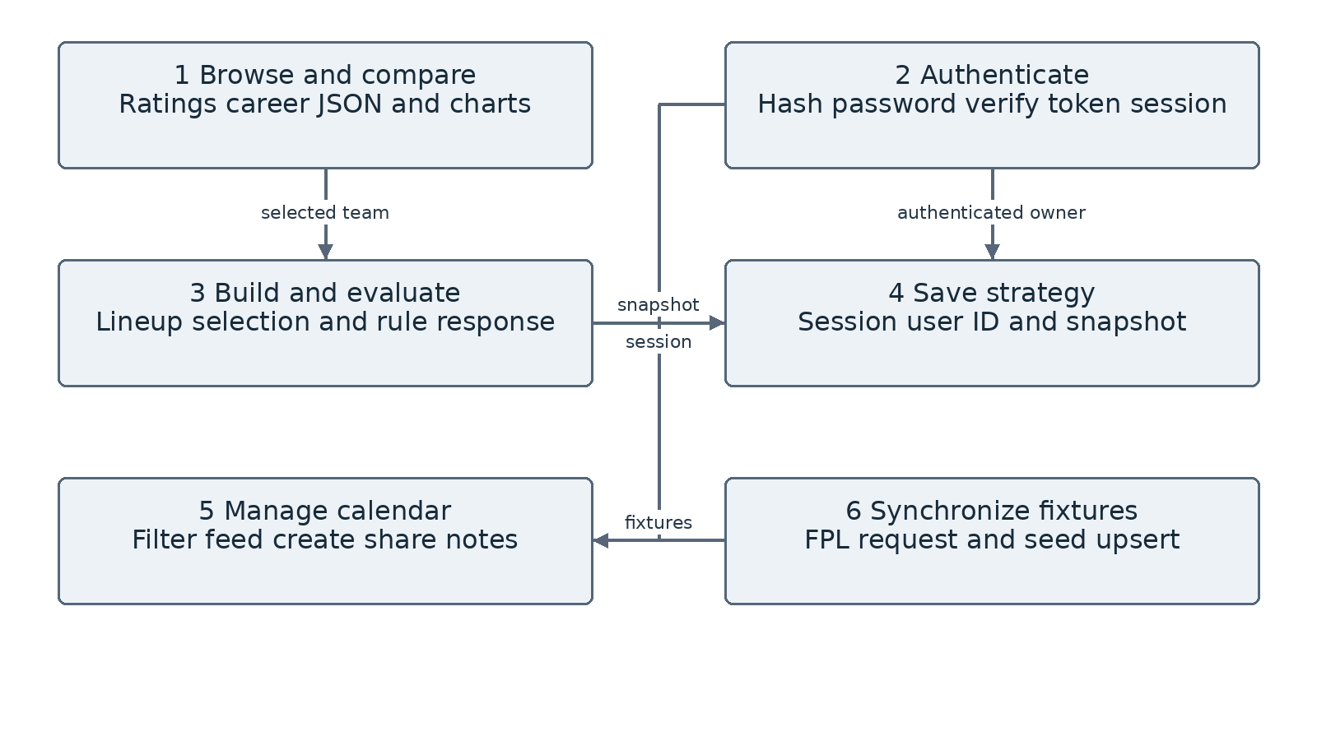
Figure 6 Level one data flow

3.6 Database Entity Relationships
The Drizzle schema declares users, email_verification_tokens, fixtures, calendar_events, event_shares, sync_logs, and saved_strategies. The figure shows their logical relationships as used by application code. No foreign-key references are declared in the inspected schema, so connecting lines must not be read as enforced database constraints.
users has a serial primary key and unique email. Tokens have a unique token string and expiry, linked to an email by application logic. Strategies contain an owner identifier and store lineup and tactical plan as text containing JSON. Events can link to a fixture, and share records associate an event with a recipient and permission.
Fixtures use a text identifier and unique deduplication key. Sync logs record competition, status, count, message, and timestamp. The current schema does not normalise individual player assignments into separate rows.
Production database records, backups, and migrations were not available for inspection. The supplied persistence test expects the schema to exist already. Local file tests therefore support conclusions about their exercised storage branch only.
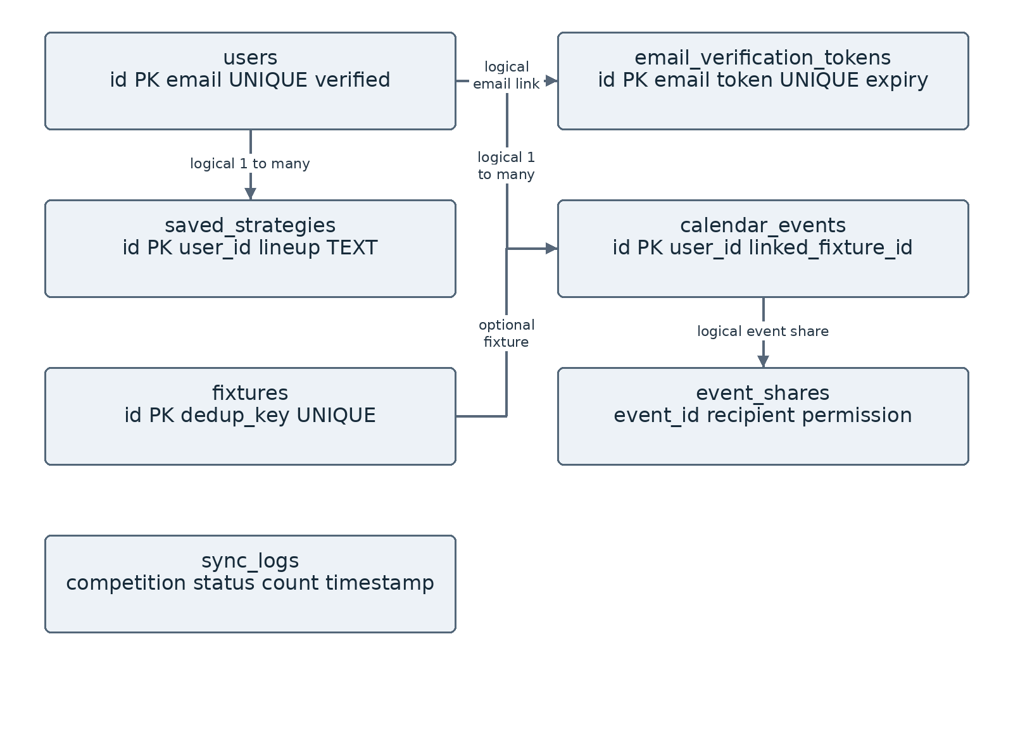
Figure 7 Database entities and logical relationships

3.7 Authentication and Verification Sequence
Signup normalises email, validates name and passwords, creates or updates an unverified account, and stores a random verification token with a one-hour lifetime. It then calls the email service using an absolute application URL. A failed provider request leaves a created or updated unverified record.
Opening a valid link marks the account verified, deletes the used token, and sets a signed session. Login independently checks the password and rejects an unverified account. Logout deletes the cookie. Resend checks the most recent token and applies a 60-second cooldown.
The diagram represents the implemented account flow. General email delivery requires a fresh inbox test with a configured sender.
Token storage and logging should be reviewed as part of production security hardening.
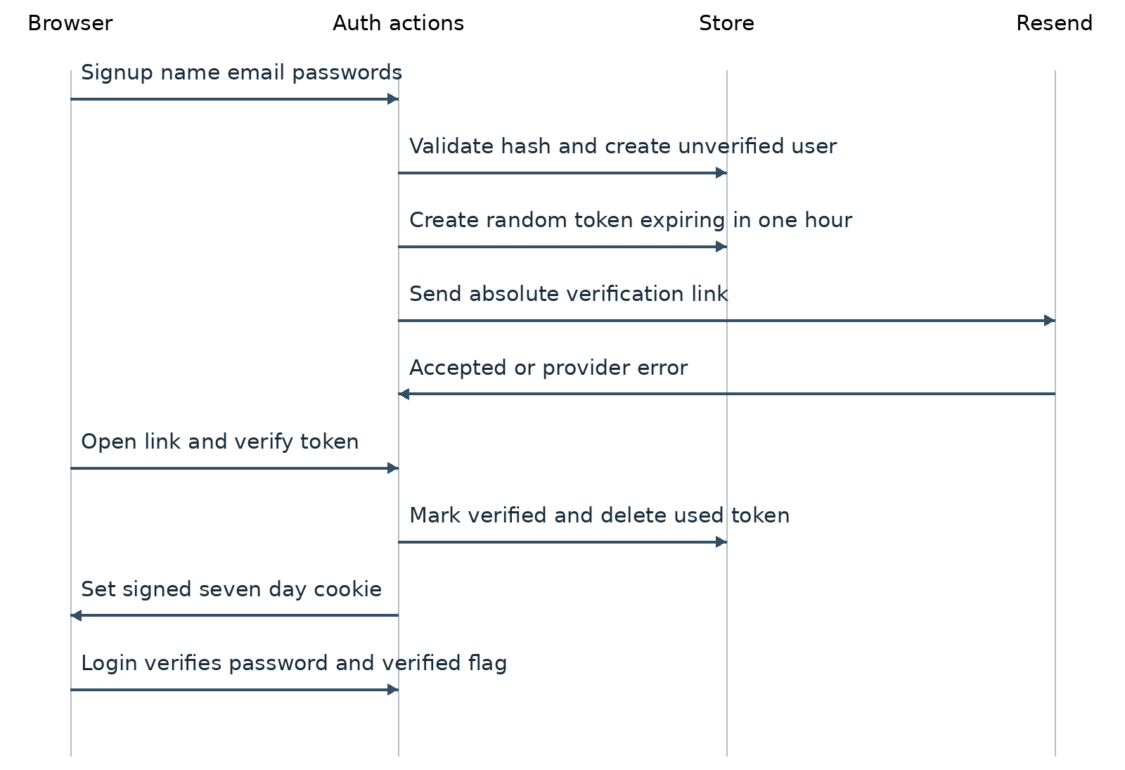
Figure 8 Signup verification and login sequence

3.8 Strategy and Saved Strategy Sequences
Generating an XI requests an initial tactical plan. Subsequent drag and swap actions update local state and record a pending change. Evaluate Strategy then requests fresh feedback for the modified arrangement.
The route receives player attributes and role labels. A change targeting a recognised forward label is marked Risky when the moved player is defensive; other moves receive generic Reasonable text. Chat does not call this route. It repeats a plan-based response regardless of the user’s question.
Saved strategies use separate server actions. Their snapshot contains formation, player identifiers, slot labels, x/y coordinates, notes, and optional feedback. Reopening restores the snapshot subject to current eligibility and identity checks. The supplied local tests establish storage behaviour, not signed-in browser restoration.
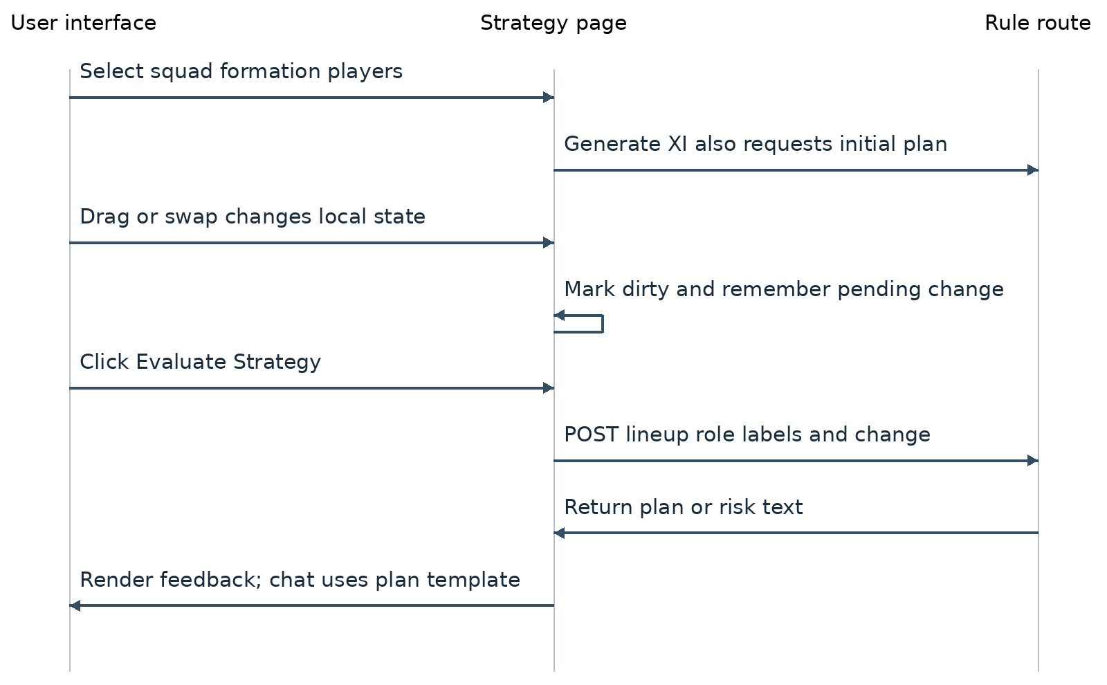
Figure 9 Lineup generation and evaluation sequence

3.9 Saved Strategy Storage and Supporting Flows
The calendar flow supports public fixtures and session-scoped personal events. SWR revalidates the feed on focus and after selected mutations. This is request-based refresh rather than a WebSocket or server-sent-event collaboration channel. The production fixture-sync action was not invoked because it can update shared data.
Deployment is described in Chapter 6. The application requires dependencies, a build environment, public assets, server functions, and configured external services.
The saved-strategy flow below complements the preceding evaluation sequence. It shows where session-derived ownership is applied. A strategy can be duplicated only after an owner-authorised read. The local supplied test verified create, list, isolation, update, duplication, and deletion using synthetic user identifiers.
Production sharing and persistence tests require a designated account and an isolated database. The schema defines the relevant records, but the original assessment did not verify their durability on the deployed host.
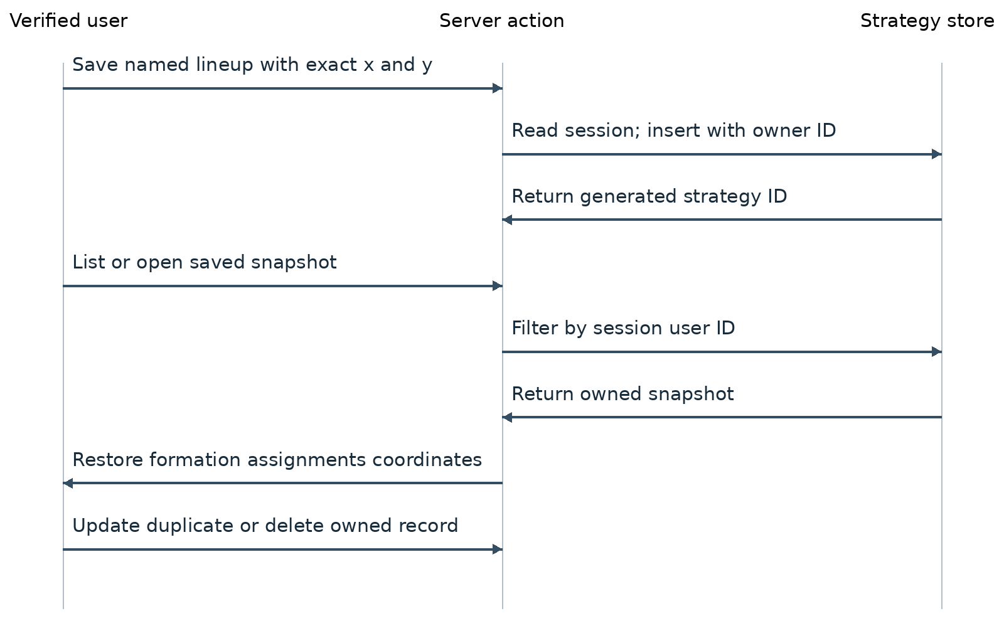
Figure 10 Saved strategy operations

4 Dashboard and Application Shell
The dashboard provides a competition selector, matchup controls, summary cards, and a highest-rated player list. The World Cup view displayed 1,248 player records and 48 national teams during testing. These counts describe the loaded dataset.
The shell consistently exposes login and signup while signed out. Its sidebar correctly instructs users to adjust a lineup and click Evaluate Strategy. The dashboard labels Elo preview and prediction as Model Estimate. It does not show a verified retrieval date beside every rating.
The initial screenshot also records a duplicated Lamine Yamal Yamal display name and ungrouped 1248 count. The domestic context later displayed full club names such as Arsenal FC and Aston Villa FC. However, its highest-rated list included historical squad associations, so current-season wording needs care.
The dashboard average is calculated from team overall values. Squad averages elsewhere use individual player overall values. The captions should identify which average is being displayed.
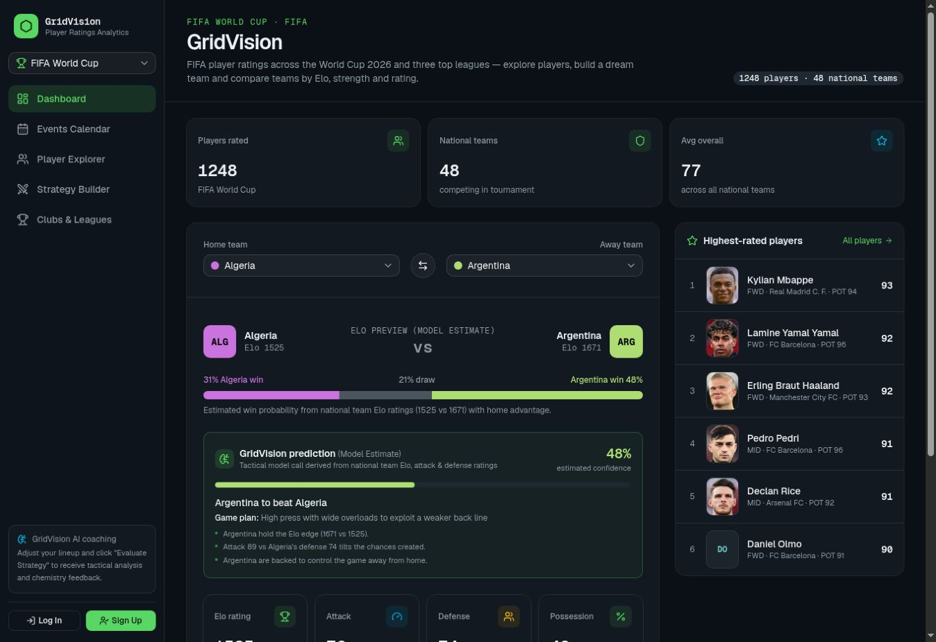
Figure 11 Dashboard in World Cup mode

4.1 Player Explorer Search and Filters
Player Explorer reads the career dataset independently of the global competition selection. The live page showed 1,724 total records, 1,406 active, 317 retired, and one uncertain/unattached. These are stored classifications. They were not individually reverified against current official rosters.
Text search checks lowercased name, club, and nationality. Status, position, club, and text conditions are combined before sorting. The first 100 rows are shown and Show more increases the visible limit. Search for Messi returned one record; a deliberately absent term returned the empty-state message.
Sorting supports career goals, assists, appearances, and age. The comparator is always descending. The earlier requested ascending and descending age control is not implemented in this page. The visible dropdown values ALL and goals also expose internal keys instead of their intended user-facing labels.
No market-value column was visible in the sampled explorer. Monetary properties and a legacy formatter still exist in the data module. Their removal from the interface does not mean the underlying datasets no longer contain them.
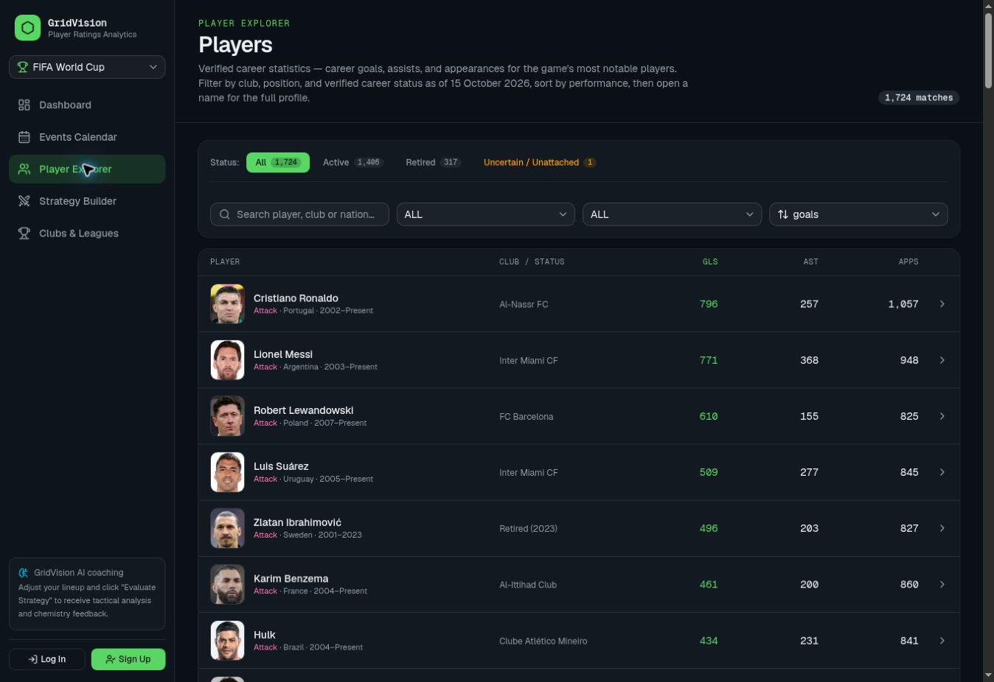
Figure 12 Player Explorer with search and filters

4.2 Player Profiles and Career Status
The sampled Lionel Messi page displayed a headshot, career span, status, nationality, physical details, career totals, and competition names. A status note and source label were also visible. This test confirmed rendering; it did not independently verify every displayed football fact.
careerSpan formats active records as start–Present and retired records with retirementYear or a lastYear fallback. Local tests confirmed the formatting distinction. However, the career-verification generation script assigns generic source descriptions and an as-of date to records without a curated override, and may copy lastYear into retirementYear. That weakens any blanket claim that every displayed retirement endpoint is individually verified.
The separate ratings-to-career matcher normalises accents and tokens and adds bonuses for club or nationality. It is deterministic but is not a verified identity registry. Ambiguous single-name players and outdated club associations can still cause mismatches; uncertain matches should use an initials fallback.
The project should retain distinct dates for statistics coverage, status verification, image retrieval, and page generation. Updating a career label to Present does not update career goals, appearances, club affiliation, or the photograph.
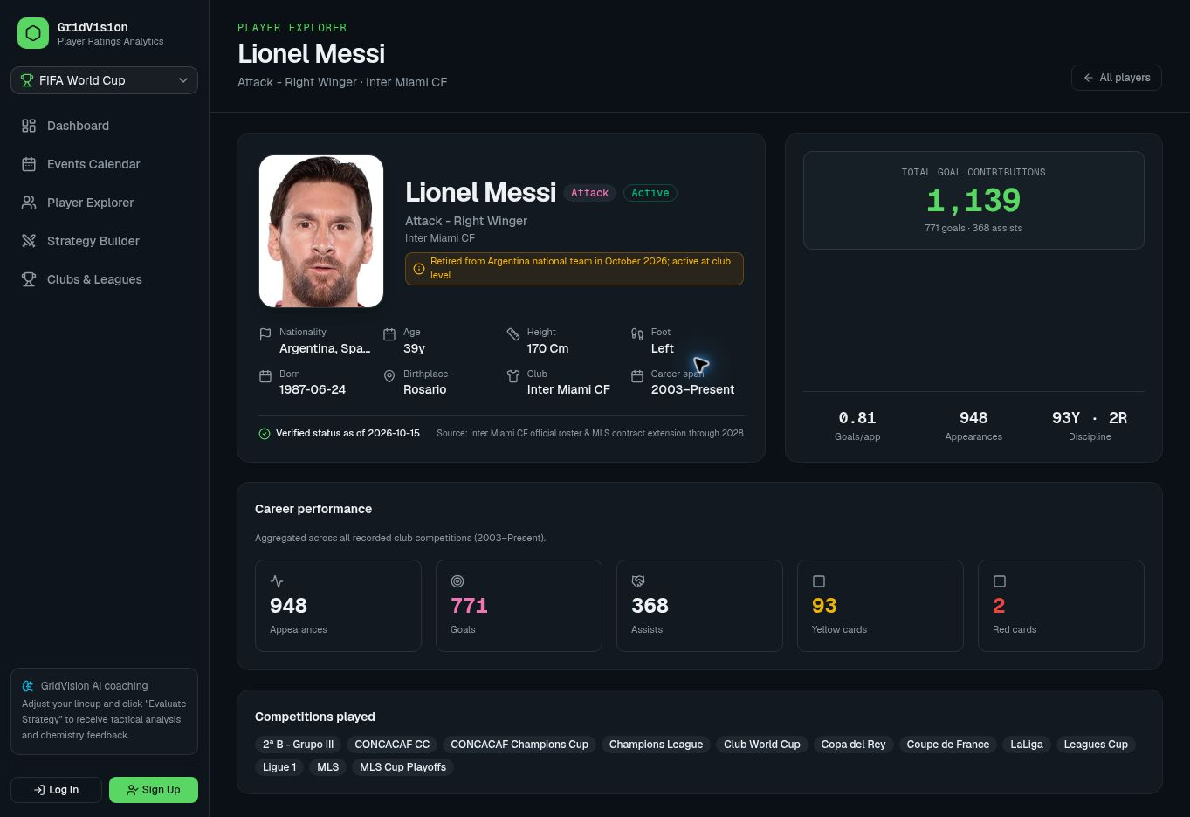
Figure 13 Sample player profile

4.3 Player Photographs and Presentation
PlayerAvatar is reused to provide consistent portrait, square, or circular containers. It supports sizes from compact thumbnails to profile images, object-cover or object-contain fitting, and a fixed crop focus near the upper part of a portrait. Failed images fall back to initials.
For profile size, a Transfermarkt /portrait/big/ URL is first changed to /portrait/original/. If that fails, the component retries the big version before showing initials. Image loading is lazy and uses no-referrer. The component keeps its URL in local state, so changes to the image prop during reuse should be tested rather than assumed to reset correctly.
The headshot script obtains a player image URL from a profile linked to that player’s identifier. No image-generation call was found in the inspected avatar or update paths. Image rights and capture dates still need to be recorded separately.
Consistent cropping improves presentation, while accurate identity matching determines whether the correct player is shown. An image record should retain the player ID, source page, permitted use, and retrieval date.
The screenshots show sampled images that rendered successfully. Comprehensive checks of identity, recency, reuse rights, and error fallbacks remain in the test plan.
Table 7 Player Photographs and Presentation
Presentation mechanism | Implemented behaviour | Remaining check
Portrait container | Shared responsive size classes | Compare all breakpoint crops
Image fallback | Original to big to initials | Force both error paths
Identity matching | Name tokens with club/nation bonus | Ambiguous and duplicate names
Recency and permission | No complete ledger found | Confirm source terms and dates

4.4 Clubs Leagues and Tactical Style
The overview uses context-aware headings. In World Cup mode the live title was National Teams & Tournaments, with a Tournament Table by Elo. The table and charts are generated from the selected competition’s team aggregates. Clicking France opened a tactical-style panel.
The panel presents primary and alternative styles, scores, supporting attributes, strengths, and key players. It identifies these as suggestions calculated from squad ratings. They should be read as an interpretation of the dataset rather than observed match tactics.
The module scores possession, counterattack, high pressing, and defensive organisation. It compares positional attributes with competition benchmarks and chooses key players from their attribute profiles. The calculation is deterministic.
An Active count is calculated as total squad players minus those matched as retired. Failure to match a retired player is therefore not affirmative evidence of current activity. The UI should avoid representing that count as a fully verified eligibility list.
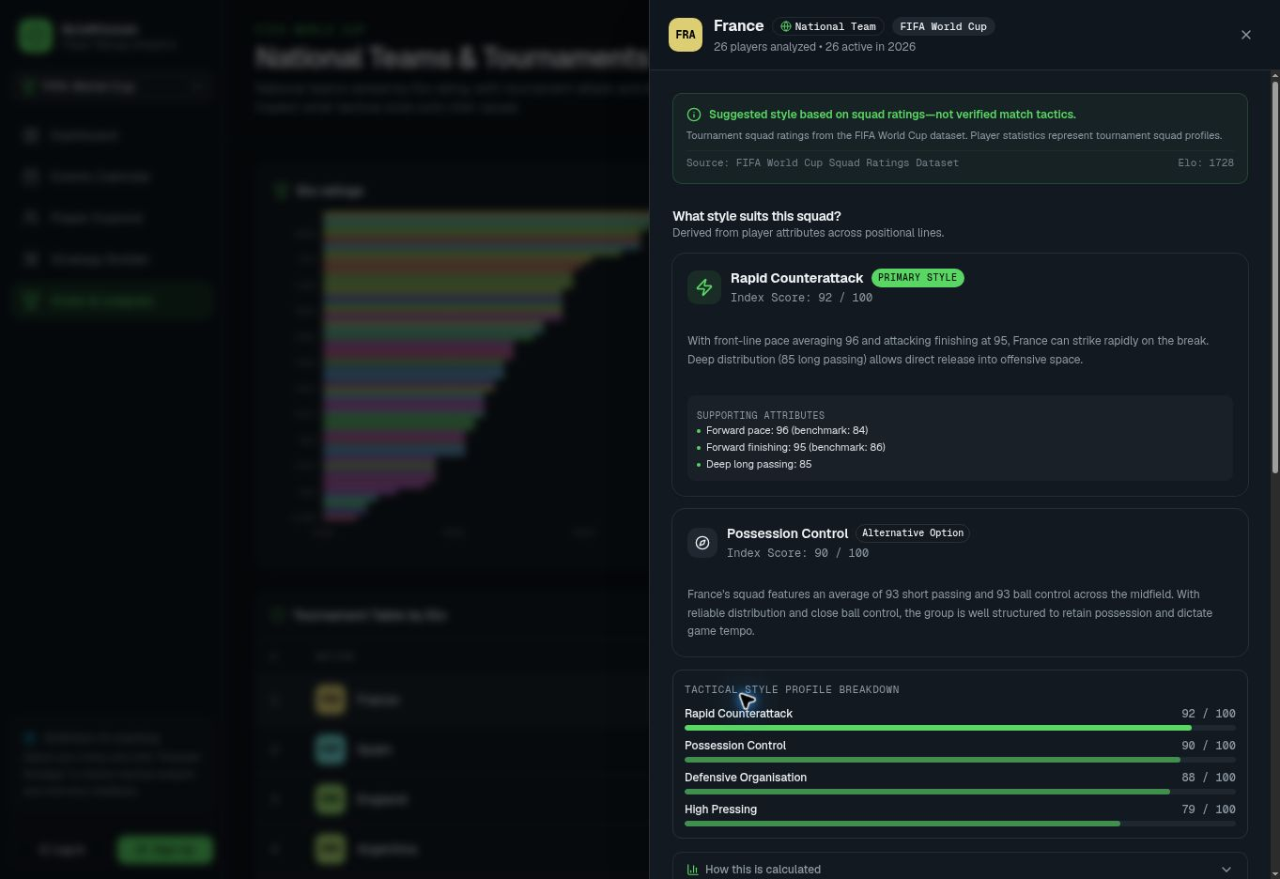
Figure 14 Tactical style suggestions for France

4.5 Ratings Predictions and Analytical Methods
Team attack uses the six highest-overall forwards or midfielders and averages shooting, dribbling, and pace. Defence uses up to six defenders or goalkeepers and averages defending and physicality. Values are min-max scaled within the selected competition to 58–94. Team overall is the rounded mean of attack and defence.
The fallback Elo-like value is round(1300 + ((overall − 55) / 40) × 450). It is derived from attributes and is not a demonstrated historical Elo update process. The matchup calculation adds 70 home-advantage points and uses a base-10 logistic expectation with denominator 400. A draw share is added and rounded percentages sum to 100.
Projected possession is a separate bounded heuristic based on attack/defence differences, constrained to 30–70 percent. The prediction module selects the highest outcome percentage and describes a style from rating gaps. Its confidence is the selected model percentage, not measured accuracy on held-out games.
The World Cup generator derives overall from log market value, caps, and average match rating. It adds position-based offsets and deterministic seeded variation to attribute groups. These generated FIFA-like attributes must not be presented as official EA ratings or observed match statistics.
Style scores are weighted attribute indices. For example, possession combines midfield passing 30 percent, control 25 percent, outfield dribbling 20 percent, vision 15 percent, and long passing 10 percent. None of these formulas establishes causal tactical superiority or calibrated forecasts.
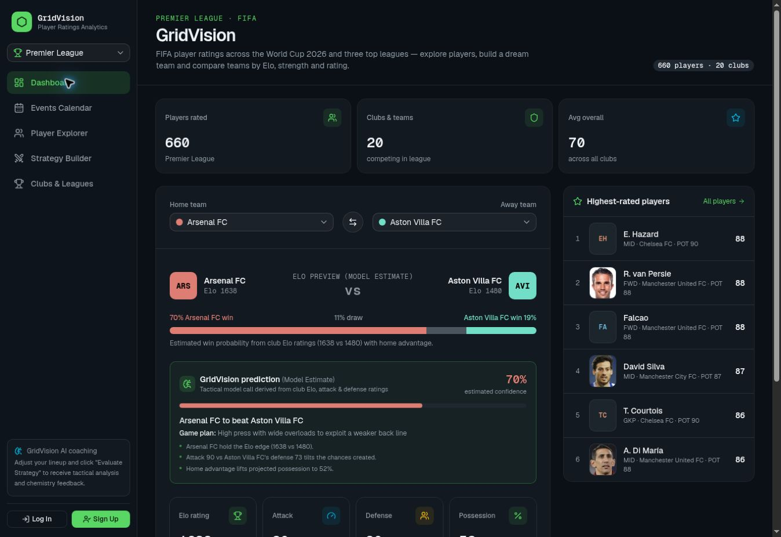
Figure 15 Dashboard in Premier League mode
Table 8 Ratings Predictions and Analytical Methods
Output | Method | Interpretation
Overall and strength | Attribute averages and scaling | Within-snapshot derived index
Elo preview | Logistic heuristic with home advantage | Model estimate
Style score | Weighted positional attributes | Suggested squad suitability
Strategy plan | Thresholds and text templates | Rules-based feedback
Chat answer | Local plan template | Not demonstrated model dialogue

4.6 Interactive Strategy Builder
The source supports club and Dream Team modes, formation slots, selected players, assignments, and pitch coordinates. A player picker filters used and recognised retired players. The page also checks existing assignments for retired or otherwise ineligible players before evaluation.
The pitch component converts pointer positions into bounded percentage coordinates and supports moving a slot or swapping assignments. Slot identifiers, line groups, labels, and player IDs are distinct concepts. Formation changes rebuild the slots; restoring a saved strategy uses its persisted coordinates.
The live signed-out route displayed Email Verification Required and links to sign in or create an account. No verified test account was supplied. Consequently, generation, dragging, swapping, formation changes, and actual browser restoration are blocked functional tests. Source review establishes their presence, not successful interaction.
The retirement filter uses normalised name matching against career records. It is scoped to the available snapshot and does not establish eligibility for every historical competition or national-team selection. The code’s current-year active restrictions can prevent generating a full XI from a historical club squad.
When fewer than eleven eligible players exist, the source displays an explanatory warning. This is preferable to silently filling a team with unrelated players, but it further demonstrates why current and historical datasets must be clearly separated.
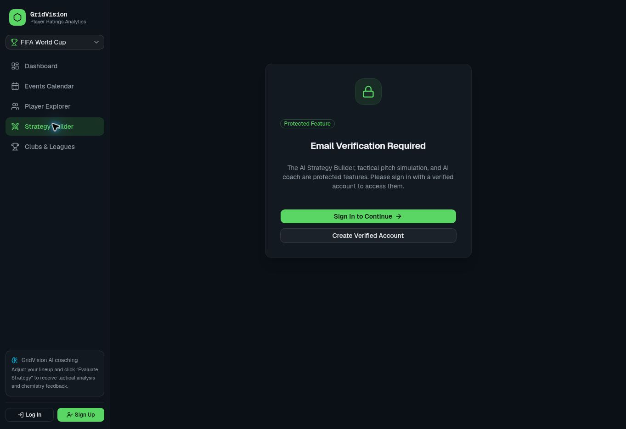
Figure 16 Strategy Builder access screen

4.7 Explicit Evaluation and Strategy Assistant
onSwap and onMove update assignments or coordinates, mark the strategy dirty, and record the pending change without calling fetch. Evaluate Strategy then submits the current reduced lineup payload. The source still contains an evaluateChange helper with a fetch call, but inspected movement handlers do not call it.
Initial XI generation is different: executeGenerate requests a plan immediately after filling the lineup. Thus the source supports no automatic analysis after dragging, while not enforcing an absolute rule that Evaluate Strategy is the only action that ever invokes analysis.
For a pending change, the route judges risk using the destination role label and the moved player’s broad position. Free movement supplies the generic destination a new position on the pitch. Exact coordinates and surrounding distances are not sent for evaluation, so spatial effects such as gaps, overloads, or defensive cover are not measured.
The right-side StrategyChat accepts messages and displays a response. handleChat constructs the answer from formation, key player, and summary. It does not interpret the question or call a model. GeminiQuickAsk is a separate component that submits unsupported ask mode and received HTTP 400 in local testing.
The correct implementation description is therefore a tactical board with rules-based plans and a templated assistant. A genuine context-aware model agent would require a supported request contract, submitted lineup state, service configuration, error handling, and dedicated evaluation.
Table 9 Explicit Evaluation and Strategy Assistant
Action | Current request behaviour | Evidence
Generate XI | Requests initial rules plan | executeGenerate source
Drag or swap | Local state and pending change | onMove onSwap source
Evaluate Strategy | POST generate or evaluate | evaluateCurrentSetup source
Strategy chat | No network; fixed plan response | handleChat source
Quick Ask | Sends unsupported ask mode | Local HTTP 400 A13

4.8 Saved Strategy Implementation
Saved snapshots include a generated ID, owner ID, name, notes, mode, competition field named season, optional team ID, team name, formation, slot array, optional tactical plan, verdict, and timestamps. Each slot preserves identifier, line, label, x/y coordinate, and selected player metadata.
Server actions obtain the current session before listing, reading, creating, updating, duplicating, or deleting strategies. Stores enforce ownership using userId. In the database, lineup and tacticalPlan are serialised JSON strings in text columns. The fallback stores the corresponding record in .data/strategy-store.json.
The provided saved-strategy suite was executed after TypeScript transpilation in an isolated directory with DATABASE_URL empty. Its six groups passed: creation, list retrieval, cross-user isolation, owner update, duplication, and owner deletion. Decimal coordinates were preserved. The test log’s phrase database is an overstatement for this run because only local JSON storage was exercised.
Browser persistence across login, reload, sessions, and deployment instances remains blocked. The UI restoration path may remap players or flag ineligible ones; the server store test does not exercise that path. A further edge case is that save validation rejects an empty array but does not establish a complete, unique, eleven-player lineup.
Production should require a working durable database and clear failure handling rather than silently switching storage modes. Backup and restore, schema migration, record size limits, and snapshot versioning are realistic maintenance tasks.
Table 10 Saved Strategy Implementation
Operation | Persisted behaviour | Executed scope
Create / list | Owner ID and full slot snapshot | Local store passed
Read another owner | Returns no record | Local store passed
Update / duplicate / delete | Ownership checked | Local store passed
Browser restore | Rebuilds state and checks eligibility | Blocked
Production restart durability | Requires external database | Blocked

4.9 Calendar Views and Fixture Synchronisation
The calendar provides month, week, and upcoming presentations. Server-side filters include competition, team, and status; type filtering is applied in the page to fixtures or personal/shared events. Dates are grouped using browser-local year, month, and day, and times use locale formatting.
Original browser testing demonstrated month navigation and competition-based filtering: the October feed reported 48 fixtures, and the Serie A selection returned eight records with four October entries. The team reported the calendar issue resolved on 23 October 2026. The earlier coverage observations remain in the test history; the calendar is no longer presented as an unchanged active defect.
The assessed synchronisation path requests FPL team and fixture data for Premier League and combines it with the application store. Other competitions use bundled fixture records in the inspected snapshot. The design separates retrieval, normalisation, persistence, and display, allowing fixture sources to be maintained without replacing the calendar interface.
Release maintenance should record the source competition, season, kickoff time, and refresh outcome for each import. Regression testing should confirm that the corrected release presents the intended date range and applies competition filters consistently. These checks validate the team-reported correction rather than assuming that older seed records represent the updated release.
B12, B15, and A16 document the original coverage and Upcoming results. Their linked issue D05 is now recorded as team-reported resolved, with independent regression evidence pending. Shared-event permissions and timezone cases retain their original Blocked or Not Run classifications.
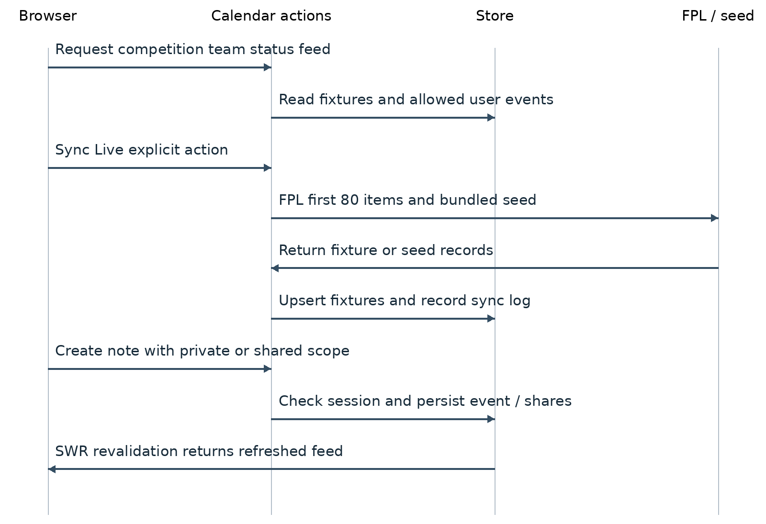
Figure 17 Calendar retrieval synchronisation and event flow

4.10 Personal Events Sharing and Refresh
Personal events support title, description, event type, start/end dates, all-day state, optional fixture and competition links, visibility, and explicit recipients. Creation requires a session and a nonempty title. Update and delete call store functions that inspect ownership or edit shares.
The live New Event / Note action displayed a sign-in requirement while logged out. This confirms the interface guard. No production events were created. Two-account visibility and mutation tests remain blocked because no designated verified accounts or isolated database were available.
getShareableUsersAction reads the local auth-store file rather than querying PostgreSQL users. On a database-only deployment it may return no candidates even when accounts exist. In the database event retrieval path, returned share metadata differs from the local path, which may affect share editing and display.
SWR refreshes the feed when focus returns and after selected local operations. Shared calendar updates use request-based refresh. Continuous updates across open user sessions would require polling or a real-time broadcast mechanism.
The month grid shows only the first three fixtures and first two personal events in each cell. Additional entries require an accessible overflow path. End-before-start dates, daylight-saving boundaries, invalid ISO strings, and view-only edits need explicit server and browser tests. The supplied actions do not demonstrate comprehensive schema validation.
Table 11 Personal Events Sharing and Refresh
Concern | Implemented path | Verification state
Logged-out event creation | Interface and action reject | Interface observed
View versus edit share | Store permission rules | Source only
Shareable user discovery | Local auth JSON lookup | Production DB gap
Cross-user updates | SWR refresh on focus/mutation | No push sync demonstrated
Timezone grouping | Browser-local date parts | Single timezone sampled

4.11 Authentication Storage and Error Handling
Passwords use PBKDF2-SHA512 with a random 16-byte salt, 10,000 iterations, and a 64-byte derived hash. Verification tokens contain 32 random bytes represented as hexadecimal. The local crypto check verified a correct password, rejected a wrong password, and checked token length; it did not assess resistance to large-scale attacks.
Sessions are JSON payloads encoded as base64url and signed with HMAC-SHA256. The cookie is HTTP-only, SameSite Lax, secure in production, and lasts seven days. The payload contains user ID, name, email, verified flag, and expiry. It is signed rather than encrypted and is not shown in this report.
A default signing-secret fallback remains in source. Email-service logs include recipient identity and the complete verification URL even in production. These are hardening concerns. Login actions block unverified users, but several personal actions check session presence rather than re-querying verification state.
Auth, calendar, and strategy stores prefer PostgreSQL when configured and fall back after some database errors. Auth and calendar local-write errors can be logged without propagating a failure; strategy local-write failures throw. This inconsistency can produce apparent success without durable data.
Email verification is implemented; general delivery remains unverified pending sender configuration and an inbox test.
Table 12 Authentication Storage and Error Handling
Control | Source finding | Remaining concern
Password storage | Salted PBKDF2 hash | Review work factor and abuse limits
Session cookie | Signed HTTP-only seven day cookie | Require strong secret and revocation plan
Verification | Random token expiry and used-token deletion | Raw token storage and logging
Resend errors | Missing key and 403 messages | General recipient delivery unverified
Storage | Postgres with JSON fallback | Fail clearly in production

5 Testing Methodology and Environment
Testing used four evidence layers: static source inspection; signed-out production interaction in Chrome; isolated local execution; and historical user-supplied screenshots. Provider documentation supplies context for operational constraints. These layers are kept separate throughout the case register.
Production observations were collected on 21 October 2026 UTC. The browser displayed Asia/Calcutta local time, where the calendar showed 22 October. Captured desktop screenshots were 1348 by 926 pixels. No mobile or tablet viewport control was available in this browser interface. A single browser engine was used.
The supplied source package was extracted separately from earlier workspace files. Its content was not modified or redeployed. For local checks, cached dependencies were linked into the assessment copy, and TypeScript modules were transpiled into an isolated harness. DATABASE_URL was empty for the saved-strategy suite; its synthetic records therefore used local JSON storage.
The test register contains 63 cases. Narrow public availability tests are separated from complete functional workflows. A login form rendering does not count as successful authentication, and an account gate does not prove server-route enforcement. Failed analytical assertions describe source behaviour rather than an unexecuted production exploit.
Release acceptance should establish a reproducible build, authenticated strategy and event persistence, aligned UI/API access control, and validated external-service configuration. Calendar regression should confirm the correction reported by the team. The original test execution did not establish all production acceptance criteria.
Table 13 Testing Methodology and Environment
Environment | Configuration | Limits
Production browser | Public Vercel HTTPS Chrome signed out | No account or inbox access
Local static check | TypeScript 5.7.3 cached dependencies | No clean lockfile install
Local runtime checks | Transpiled source and disposable JSON store | No PostgreSQL integration
Build attempt | next build --webpack | Blocked font downloads
Historical evidence | Two supplied email-error images | Not current production retest

5.1 Requirements Coverage and Status Accounting
The coverage matrix connects requirements to representative tests. Related tests can describe one underlying issue: B12 and A16 both examined future fixture coverage, while B15 examined the Upcoming list. These three baseline failures belong to D05, now reported resolved by the team. Their original results are retained for traceability.
The original register contains 63 cases: 32 Pass, 10 Fail, 17 Blocked, and four Not Run. Of the 42 executed cases, 32 met their acceptance criteria. The 23 October team update addresses three calendar-related failures; seven other failed cases remain unchanged. Calendar regression is pending, so no additional passes or revised verified pass rate are claimed.
Original public browser results were 19 Pass and five Fail. Isolated automated cases were 12 Pass and five Fail; static/build checks added one Pass and one Blocked. The remaining planned cases were 16 Blocked and four Not Run. Two browser failures and one local seed failure relate to the reported calendar correction. This update changes issue disposition, not execution history.
Severity reflects practical impact: High for an access-control boundary mismatch, Medium for analytical contracts and data presentation, and Low for labels or duplication. No Critical production data exposure was established. D05 is tracked as a reported correction rather than an unchanged open issue.
Table 14 Requirements Coverage and Status Accounting
Requirement | Tests | Evidence and gap
R01 Navigation context | B01 B16 B18–B20 B23 | Public routes observed
R02 Player discovery | B04–B08 A08 A17 C15 C20 | Search works; labels and provenance gaps
R03 Comparisons style | B02 B17 B24 A09 | Derived methods; data freshness concern
R04 Pitch evaluation | B09 A10–A15 C01 C02 C04 | Gate observed; protected browser flow blocked
R05 Saved strategies | A01–A06 C05–C08 | Local tests pass; production blocked
R06 Calendar collaboration | B10–B15 A16 C09–C12 C17 | Filtering observed; correction reported; regression pending
R07 Authentication | B18–B20 A07 C03 C13 C14 | Forms and crypto tested; delivery blocked

5.2 Detailed Test Cases B01 to B07
Original test date: 21 October 2026 UTC. PROD: public site, signed out. LOCAL: supplied version 0.1.0. PLANNED: follow-up case. Environment details and status definitions appear in Sections 5 and 5.1.
Table 15 Test cases B01 to B07
ID and objective | Environment prerequisites and exact procedure | Expected actual and evidence | Result
B01  Dashboard route and navigation | PROD  Preconditions: Signed out; World Cup selected  Steps: Open production /; inspect heading, cards and sidebar. | Expected: Dashboard and primary links render.  Actual: GridVision, five links, 1,248 players and 48 national teams displayed.  Evidence: PROD1 screenshot | Pass  Severity: —
B02  Prediction method labelling | PROD  Preconditions: Dashboard loaded  Steps: Read Elo preview and prediction captions. | Expected: Percentages identified as model estimates.  Actual: Both preview and prediction displayed Model Estimate. No forecast accuracy was tested.  Evidence: PROD1 | Pass  Severity: —
B03  Clean player display names | PROD  Preconditions: Dashboard World Cup list  Steps: Inspect highest-rated player names. | Expected: Each name appears once in its intended form.  Actual: Lamine Yamal Yamal displayed as one duplicated-name label.  Evidence: PROD1 | Fail  Severity: Low
B04  Readable player dropdown labels | PROD  Preconditions: Explorer loaded  Steps: Inspect closed filter and sort triggers. | Expected: Friendly All positions / All clubs / Career goals labels.  Actual: Triggers displayed ALL, ALL and goals; selecting Age later displayed age.  Evidence: PROD2 | Fail  Severity: Low
B05  Named-player search | PROD  Preconditions: Explorer; All status  Steps: Enter Messi in search. | Expected: Matching record appears.  Actual: One Lionel Messi result displayed.  Evidence: PROD3 DOM observation | Pass  Severity: —
B06  Empty search state | PROD  Preconditions: Explorer; All status  Steps: Enter zzzznonexistent. | Expected: Zero results and helpful empty text.  Actual: 0 matches and No players match those filters displayed.  Evidence: PROD3 screenshot | Pass  Severity: —
B07  Combined search and status | PROD  Preconditions: Messi search active  Steps: Select Retired; then All. | Expected: Retired excludes active Messi; All restores result.  Actual: 0 results under Retired; one result after All. Classification correctness itself not tested.  Evidence: PROD3 DOM observation | Pass  Severity: —

5.3 Detailed Test Cases B08 to B14
Original test date: 21 October 2026 UTC. PROD: public site, signed out. LOCAL: supplied version 0.1.0. PLANNED: follow-up case. Environment details and status definitions appear in Sections 5 and 5.1.
Table 16 Test cases B08 to B14
ID and objective | Environment prerequisites and exact procedure | Expected actual and evidence | Result
B08  Player detail navigation | PROD  Preconditions: One Messi result  Steps: Open player /28003; inspect profile. | Expected: Profile identity and career sections render.  Actual: Profile showed name, photo, active flag, career span and career totals.  Evidence: PROD4 screenshot | Pass  Severity: —
B09  Signed-out strategy guard | PROD  Preconditions: No authenticated session  Steps: Open Strategy Builder from sidebar. | Expected: Protected interaction replaced by sign-in requirement.  Actual: Email Verification Required and sign-in/signup links displayed.  Evidence: PROD5 screenshot | Pass  Severity: —
B10  Calendar fixture feed loads | PROD  Preconditions: Signed out; month October 2026  Steps: Open calendar; observe completed feed. | Expected: Month grid and fixture records render.  Actual: 48 fixtures reported; October fixture entries displayed.  Evidence: PROD6 screenshot | Pass  Severity: —
B11  Next-month navigation | PROD  Preconditions: October month view  Steps: Click Next. | Expected: Month changes to November 2026.  Actual: November 2026 heading and calendar dates displayed. Fixture coverage tested separately.  Evidence: PROD6 DOM observation | Pass  Severity: —
B12  Next-month fixture coverage | PROD  Preconditions: November 2026 month view  Steps: Inspect grid for future fixture entries. | Expected: Relevant future fixtures available or explicit coverage warning.  Actual: No fixture entries displayed; bundled seed has no November records.  Evidence: PROD6; LOCAL A16 | Fail at baseline  Fix reported  Retest pending
B13  Serie A filter highlighting | PROD  Preconditions: Return to October month view  Steps: Select Serie A; wait for feed; inspect entries. | Expected: Only selected competition fixtures remain.  Actual: Eight records reported; four October Serie A entries shown, no other league entries in view.  Evidence: PROD7 screenshot | Pass  Severity: —
B14  Logged-out note creation guard | PROD  Preconditions: Signed-out calendar  Steps: Click New Event / Note. | Expected: Sign-in required before creating a personal record.  Actual: Please sign in or create an account message displayed; no event created.  Evidence: PROD7 guard screenshot | Pass  Severity: —

5.4 Detailed Test Cases B15 to B21
Original test date: 21 October 2026 UTC. PROD: public site, signed out. LOCAL: supplied version 0.1.0. PLANNED: follow-up case. Environment details and status definitions appear in Sections 5 and 5.1.
Table 17 Test cases B15 to B21
ID and objective | Environment prerequisites and exact procedure | Expected actual and evidence | Result
B15  Upcoming view excludes historical fixtures | PROD  Preconditions: Serie A filter  Steps: Click Upcoming and inspect first entries. | Expected: Upcoming-only list starts with future entries.  Actual: List began with August 2024 matches labelled Past.  Evidence: PROD8 screenshot | Fail at baseline  Fix reported  Retest pending
B16  National-team overview | PROD  Preconditions: World Cup context  Steps: Open Clubs & Leagues. | Expected: National-team terminology, charts and table render.  Actual: National Teams & Tournaments and Tournament Table by Elo displayed.  Evidence: PROD9 screenshot | Pass  Severity: —
B17  Tactical style detail | PROD  Preconditions: Overview loaded  Steps: Inspect France tactical style. | Expected: Panel explains suggested style and supporting attributes.  Actual: France panel showed primary/alternative scores, factors, key players and method disclaimer.  Evidence: PROD9 style screenshot | Pass  Severity: —
B18  Login form availability | PROD  Preconditions: Signed out  Steps: Open Log In; inspect visible controls without submitting. | Expected: Email/password fields and sign-in button visible.  Actual: Welcome back form rendered with both fields and Sign In.  Evidence: PROD10 screenshot | Pass  Severity: —
B19  Signup form availability | PROD  Preconditions: Signed out  Steps: Open Sign Up without creating an account. | Expected: Name, email, password and confirmation visible.  Actual: All four fields and signup action displayed; community-predictions copy remains.  Evidence: PROD10 signup screenshot | Pass  Severity: —
B20  Verification landing without token | PROD  Preconditions: No verification token  Steps: Open /verify-email without query parameters. | Expected: Recovery or resend interface instead of crash.  Actual: Verify Your Email and request-link form displayed.  Evidence: PROD11 screenshot | Pass  Severity: —
B21  Removed feature presentation in sampled screens | PROD  Preconditions: Dashboard explorer profile overview inspected  Steps: Check sampled screens and current rendering source for fan votes, majority and market-value widgets. | Expected: Removed widgets absent from sampled routes.  Actual: No such visible widgets observed; legacy monetary data fields still exist. Protected screens not covered.  Evidence: PROD1 PROD2 PROD4 PROD9; SRC5 | Pass  Severity: —

5.5 Detailed Test Cases B22 to A04
Original test date: 21 October 2026 UTC. PROD: public site, signed out. LOCAL: supplied version 0.1.0. PLANNED: follow-up case. Environment details and status definitions appear in Sections 5 and 5.1.
Table 18 Test cases B22 to A04
ID and objective | Environment prerequisites and exact procedure | Expected actual and evidence | Result
B22  Desktop layout sample | PROD  Preconditions: 1348 by 926 captured viewport  Steps: Review dashboard explorer calendar and modal screenshots. | Expected: Core content and navigation readable without overlap in sampled viewport.  Actual: Sampled desktop screens readable; this does not validate mobile or all states.  Evidence: PROD1–PROD11 | Pass  Severity: —
B23  Competition switch updates domestic dashboard | PROD  Preconditions: Selector in World Cup mode  Steps: Select Premier League; open Dashboard. | Expected: Domestic team names and competition counts update.  Actual: 660 players, 20 clubs, Arsenal FC and Aston Villa FC shown.  Evidence: PROD12 screenshot | Pass  Severity: —
B24  Current-season implication matches domestic data | PROD  Preconditions: Premier League dashboard  Steps: Inspect highest-rated players and squad examples. | Expected: Current-looking interface identifies historical snapshot when used.  Actual: Historical associations including M. Özil at Arsenal and R. van Persie at Manchester United appeared without a clear date in the dashboard view.  Evidence: PROD12; SRC10 | Fail  Severity: Medium
A01  Saved strategy creation and coordinates | LOCAL  Preconditions: Isolated transpiled supplied store; DATABASE_URL empty  Steps: Run supplied group 1 with synthetic user 8881 and eleven slots. | Expected: ID owner and exact decimal positions preserved.  Actual: Created snapshot retained eleven slots and coordinates 18.5 / 72.4.  Evidence: LOCAL1 saved-suite log | Pass  Severity: —
A02  Owner saved list | LOCAL  Preconditions: Isolated transpiled supplied store; DATABASE_URL empty  Steps: Run supplied group 2 after creation. | Expected: Owner list includes created strategy.  Actual: Owner list contained the created ID.  Evidence: LOCAL1 saved-suite log | Pass  Severity: —
A03  Cross-user store isolation | LOCAL  Preconditions: Isolated transpiled supplied store; DATABASE_URL empty  Steps: Run group 3 as synthetic user 8882: list read update duplicate delete. | Expected: Other owner record unavailable and mutations rejected.  Actual: List excluded record; read returned null; update duplicate and delete threw.  Evidence: LOCAL1 saved-suite log | Pass  Severity: —
A04  Owner update preserves moved slot | LOCAL  Preconditions: Isolated transpiled supplied store; DATABASE_URL empty  Steps: Run group 4 with slot 10 x=84.2 y=24.8. | Expected: Updated notes and exact coordinates persist.  Actual: Both coordinates and notes matched assertions.  Evidence: LOCAL1 saved-suite log | Pass  Severity: —

5.6 Detailed Test Cases A05 to A10
Original test date: 21 October 2026 UTC. PROD: public site, signed out. LOCAL: supplied version 0.1.0. PLANNED: follow-up case. Environment details and status definitions appear in Sections 5 and 5.1.
Table 19 Test cases A05 to A10
ID and objective | Environment prerequisites and exact procedure | Expected actual and evidence | Result
A05  Owner duplicate | LOCAL  Preconditions: Isolated transpiled supplied store; DATABASE_URL empty  Steps: Run group 5 on updated record. | Expected: New ID copy name and coordinates retained.  Actual: Copy had distinct ID, (Copy) suffix and retained x=84.2.  Evidence: LOCAL1 saved-suite log | Pass  Severity: —
A06  Owner deletion | LOCAL  Preconditions: Isolated transpiled supplied store; DATABASE_URL empty  Steps: Run group 6 deleting both synthetic records then list. | Expected: Deleted IDs absent.  Actual: Both deletions succeeded and neither ID remained.  Evidence: LOCAL1 saved-suite log | Pass  Severity: —
A07  Password hash verifies and rejects wrong password | LOCAL  Preconditions: Isolated source invocation; no production request  Steps: Call password hash and verification functions with correct and wrong passwords; create token. | Expected: Correct accepted wrong rejected and token 64 hex characters.  Actual: Assertions satisfied  Evidence: LOCAL2 assertions log | Pass  Severity: —
A08  Career spans separate status from statistical cutoff | LOCAL  Preconditions: Isolated source invocation; no production request  Steps: Format an active and retired sample from the supplied career data. | Expected: Active ends Present; retired ends stored retirement year.  Actual: Lamine Yamal: 2022–Present; Emiliano Sala: 2011–2018  Evidence: LOCAL2 assertions log | Pass  Severity: —
A09  Model probabilities remain normalized | LOCAL  Preconditions: Isolated source invocation; no production request  Steps: Evaluate every home/away pair in all four competition datasets. | Expected: Outcome percentages sum to 100; possession sums to 100; outcomes nonnegative.  Actual: Assertions satisfied  Evidence: LOCAL2 assertions log | Pass  Severity: —
A10  Rules generate a plan | LOCAL  Preconditions: Isolated source invocation; no production request  Steps: Invoke strategy POST generate with one synthetic defender and 4-3-3. | Expected: Structured rules plan names supplied player.  Actual: HTTP 200; plan summary included Defender Sample; strongest/best passer/fastest all used the supplied record.  Evidence: LOCAL2 assertions log | Pass  Severity: —

5.7 Detailed Test Cases A11 to A16
Original test date: 21 October 2026 UTC. PROD: public site, signed out. LOCAL: supplied version 0.1.0. PLANNED: follow-up case. Environment details and status definitions appear in Sections 5 and 5.1.
Table 20 Test cases A11 to A16
ID and objective | Environment prerequisites and exact procedure | Expected actual and evidence | Result
A11  Defender to forward role gets risk warning | LOCAL  Preconditions: Isolated source invocation; no production request  Steps: Invoke evaluate for synthetic DEF moving CB to ST. | Expected: Risky verdict for defensive player moved forward.  Actual: Verdict Risky; warning about defensive cover and transitions.  Evidence: LOCAL2 assertions log | Pass  Severity: —
A12  Free pitch movement receives spatially meaningful feedback | LOCAL  Preconditions: Isolated source invocation; no production request  Steps: Invoke evaluate using actual free-move destination string. | Expected: Feedback distinguishes spatial effect or states unavailable coordinates.  Actual: Verdict Reasonable for generic destination; no coordinate or distance analysis.  Evidence: LOCAL2 assertions log | Fail  Severity: Medium
A13  Quick Ask request supported by API | LOCAL  Preconditions: Isolated source invocation; no production request  Steps: Invoke POST with mode ask and a tactical question. | Expected: Quick Ask contract returns a supported answer.  Actual: Actual HTTP 400 {"error":"Invalid request."}  Evidence: LOCAL2 assertions log | Fail  Severity: Medium
A14  Strategy API enforces authentication | LOCAL  Preconditions: Isolated source invocation; no production request  Steps: Invoke generate handler without a session. | Expected: 401 or 403 consistent with protected-feature claim.  Actual: Unauthenticated handler returns HTTP 200  Evidence: LOCAL2 assertions log | Fail  Severity: High
A15  Malformed strategy JSON returns controlled response | LOCAL  Preconditions: Isolated source invocation; no production request  Steps: Invoke handler with malformed JSON body containing an opening brace. | Expected: Controlled response returned without uncaught parser exception.  Actual: Expected property name or '}' in JSON at position 1 (line 1 column 2)  Evidence: LOCAL2 assertions log | Fail  Severity: Medium
A16  Seed covers next calendar month | LOCAL  Preconditions: Isolated source invocation; no production request  Steps: Inspect all seed kickoffTime strings for November 2026. | Expected: At least one next-month fixture or explicit coverage metadata.  Actual: No November 2026 fixture in 48 seed records  Evidence: LOCAL2 assertions log | Fail at baseline  Fix reported  Retest pending

5.8 Detailed Test Cases A17 to C03
Original test date: 21 October 2026 UTC. PROD: public site, signed out. LOCAL: supplied version 0.1.0. PLANNED: follow-up case. Environment details and status definitions appear in Sections 5 and 5.1.
Table 21 Test cases A17 to C03
ID and objective | Environment prerequisites and exact procedure | Expected actual and evidence | Result
A17  Career IDs are unique | LOCAL  Preconditions: Isolated source invocation; no production request  Steps: Compare career ID set size with array length. | Expected: All 1,724 career identifiers unique.  Actual: Assertions satisfied  Evidence: LOCAL2 assertions log | Pass  Severity: —
Q01  TypeScript static check | LOCAL  Preconditions: Supplied source; cached Next.js 16.3.3 dependencies  Steps: Run tsc --noEmit --incremental false. | Expected: Exit 0 without diagnostics.  Actual: Completed with exit 0 and empty diagnostic log.  Evidence: LOCAL3 typecheck log | Pass  Severity: —
Q02  Fresh production build | LOCAL  Preconditions: Same source and cached dependency environment  Steps: Run npm run build using supplied webpack script. | Expected: Optimised production build completes.  Actual: Google Geist and Geist Mono font downloads unavailable; build did not complete. No source edits or network bypass.  Evidence: LOCAL4 build log | Blocked  Severity: —
C01  Verified browser lineup generation | PLANNED  Preconditions: Designated verified account  Steps: Sign in securely; select club with eleven eligible players; Generate XI. | Expected: Exactly eleven unique eligible assignments and initial plan.  Actual: Blocked: required designated account, isolated service, controlled test data or viewport capability unavailable. No production mutation performed.  Evidence: Coverage plan; SRC only | Blocked  Severity: —
C02  Formation dragging swapping and explicit evaluation | PLANNED  Preconditions: Verified account and generated XI  Steps: Change formation; drag and swap; inspect requests; click Evaluate Strategy. | Expected: No move-triggered request; explicit action submits current lineup; roles remain consistent.  Actual: Blocked: required designated account, isolated service, controlled test data or viewport capability unavailable. No production mutation performed.  Evidence: Coverage plan; SRC only | Blocked  Severity: —
C03  Registration and actual verification inbox delivery | PLANNED  Preconditions: Disposable mailbox and approved test account flow  Steps: Register once; inspect provider event; independently confirm inbox/spam receipt and open link. | Expected: Correct recipient receives valid public HTTPS link and becomes verified.  Actual: Blocked: required designated account, isolated service, controlled test data or viewport capability unavailable. No production mutation performed.  Evidence: Coverage plan; SRC only | Blocked  Severity: —

5.9 Detailed Test Cases C04 to C09
Original test date: 21 October 2026 UTC. PROD: public site, signed out. LOCAL: supplied version 0.1.0. PLANNED: follow-up case. Environment details and status definitions appear in Sections 5 and 5.1.
Table 22 Test cases C04 to C09
ID and objective | Environment prerequisites and exact procedure | Expected actual and evidence | Result
C04  Retired-player restriction | PLANNED  Preconditions: Verified account; recognised retired test player  Steps: Search retired player in picker; attempt restore from old saved snapshot. | Expected: Retired player excluded or flagged and evaluation blocked until replaced.  Actual: Blocked: required designated account, isolated service, controlled test data or viewport capability unavailable. No production mutation performed.  Evidence: Coverage plan; SRC only | Blocked  Severity: —
C05  Saved strategy browser persistence | PLANNED  Preconditions: Verified account and disposable strategy  Steps: Save; reload; log out and back in; reopen. | Expected: Formation players decimal coordinates notes and snapshots restored.  Actual: Blocked: required designated account, isolated service, controlled test data or viewport capability unavailable. No production mutation performed.  Evidence: Coverage plan; SRC only | Blocked  Severity: —
C06  Saved strategy browser update duplicate delete | PLANNED  Preconditions: Verified account; disposable own record  Steps: Move a player; update; reopen; duplicate; delete disposable copy. | Expected: Update retained; copy independent; deleted copy absent.  Actual: Blocked: required designated account, isolated service, controlled test data or viewport capability unavailable. No production mutation performed.  Evidence: Coverage plan; SRC only | Blocked  Severity: —
C07  Production cross-account strategy isolation | PLANNED  Preconditions: Two designated verified accounts  Steps: Create under A; attempt list read update duplicate delete as B. | Expected: B cannot access or modify A record through UI or server actions.  Actual: Blocked: required designated account, isolated service, controlled test data or viewport capability unavailable. No production mutation performed.  Evidence: Coverage plan; SRC only | Blocked  Severity: —
C08  Database restart and deployment persistence | PLANNED  Preconditions: Dedicated PostgreSQL instance and schema  Steps: Run provided database suite; restart app; reopen test records; clean disposable records. | Expected: Persistence and ownership survive process change without local fallback.  Actual: Blocked: required designated account, isolated service, controlled test data or viewport capability unavailable. No production mutation performed.  Evidence: Coverage plan; SRC only | Blocked  Severity: —
C09  Personal-event persistence and date boundaries | PLANNED  Preconditions: Verified account and disposable event  Steps: Create training note; reload; reopen; test end-before-start validation. | Expected: Record survives and invalid dates produce clear rejection.  Actual: Blocked: required designated account, isolated service, controlled test data or viewport capability unavailable. No production mutation performed.  Evidence: Coverage plan; SRC only | Blocked  Severity: —

5.10 Detailed Test Cases C10 to C15
Original test date: 21 October 2026 UTC. PROD: public site, signed out. LOCAL: supplied version 0.1.0. PLANNED: follow-up case. Environment details and status definitions appear in Sections 5 and 5.1.
Table 23 Test cases C10 to C15
ID and objective | Environment prerequisites and exact procedure | Expected actual and evidence | Result
C10  Shared-event view and edit permissions | PLANNED  Preconditions: Two verified accounts and disposable shared event  Steps: Share view-only; attempt edit as recipient; grant edit; repeat; test delete. | Expected: View-only cannot edit; edit grant limited; owner controls deletion and shares.  Actual: Blocked: required designated account, isolated service, controlled test data or viewport capability unavailable. No production mutation performed.  Evidence: Coverage plan; SRC only | Blocked  Severity: —
C11  Team filters and reset with complete feed | PLANNED  Preconditions: Stable verified fixture feed across teams  Steps: Select league; enter team; apply status and type; reset. | Expected: Intersected records correct and reset restores feed; unrelated notes handled intentionally.  Actual: Blocked: required designated account, isolated service, controlled test data or viewport capability unavailable. No production mutation performed.  Evidence: Coverage plan; SRC only | Blocked  Severity: —
C12  Timezone and calendar month boundaries | PLANNED  Preconditions: Controllable alternate timezone and fixture near midnight  Steps: Compare UTC and Asia/Calcutta then a daylight-saving timezone; navigate month end. | Expected: Consistent local dates and no setMonth overflow skipping months.  Actual: Blocked: required designated account, isolated service, controlled test data or viewport capability unavailable. No production mutation performed.  Evidence: Coverage plan; SRC only | Blocked  Severity: —
C13  Verification expiry replay and resend cooldown | PLANNED  Preconditions: Disposable account tokens and inbox  Steps: Use token once; retry; expire another token; resend twice within 60 seconds. | Expected: Used/expired links rejected; cooldown enforced; new valid link succeeds.  Actual: Blocked: required designated account, isolated service, controlled test data or viewport capability unavailable. No production mutation performed.  Evidence: Coverage plan; SRC only | Blocked  Severity: —
C14  Verified login unverified login logout and protected actions | PLANNED  Preconditions: Designated verified and unverified accounts  Steps: Try both account states; log out verified session; revisit protected actions. | Expected: Only verified login succeeds; logout removes access; forged or expired session rejected.  Actual: Blocked: required designated account, isolated service, controlled test data or viewport capability unavailable. No production mutation performed.  Evidence: Coverage plan; SRC only | Blocked  Severity: —
C15  Image fallback and uncertain identity | PLANNED  Preconditions: Controlled missing and ambiguous image fixtures  Steps: Use broken original and big image URLs; change image prop; inspect initials. | Expected: No wrong identity; initials remain readable; state updates correctly.  Actual: Blocked: required designated account, isolated service, controlled test data or viewport capability unavailable. No production mutation performed.  Evidence: Coverage plan; SRC only | Blocked  Severity: —

5.11 Detailed Test Cases C16 to C20
Original test date: 21 October 2026 UTC. PROD: public site, signed out. LOCAL: supplied version 0.1.0. PLANNED: follow-up case. Environment details and status definitions appear in Sections 5 and 5.1.
Table 24 Test cases C16 to C20
ID and objective | Environment prerequisites and exact procedure | Expected actual and evidence | Result
C16  Mobile and tablet layouts | PLANNED  Preconditions: Controllable 390px and 768px browser viewports  Steps: Inspect navigation player rows pitch calendar and dialogs at both widths. | Expected: No horizontal clipping; touch controls and text remain usable.  Actual: Blocked: required designated account, isolated service, controlled test data or viewport capability unavailable. No production mutation performed.  Evidence: Coverage plan; SRC only | Blocked  Severity: —
C17  Live fixture sync mutation and feed failure | PLANNED  Preconditions: Isolated fixture store with provider access  Steps: Run Sync Live per competition; simulate timeout and non-OK response. | Expected: Current season complete fixtures; honest partial/failure status.  Actual: Not run on production because it updates shared fixture records.  Evidence: Manual follow-up procedure | Not Run  Severity: —
C18  Performance and abuse controls | PLANNED  Preconditions: Approved staging environment  Steps: Measure ordinary page timing and limited validation requests within agreed bounds. | Expected: Documented budgets and effective request limits.  Actual: Not run; no load or intrusive security testing authorised.  Evidence: Manual follow-up procedure | Not Run  Severity: —
C19  Cross-browser interaction | PLANNED  Preconditions: Second browser engine and device configuration  Steps: Repeat critical navigation pitch dialogs and calendar flows. | Expected: Equivalent functionality with supported browsers.  Actual: Not run; only the available Chrome session used.  Evidence: Manual follow-up procedure | Not Run  Severity: —
C20  External player fixture and image accuracy | PLANNED  Preconditions: Traceable official records and licence ledger  Steps: Sample players clubs retirement dates fixture dates and photo provenance. | Expected: Each statement linked to dated primary evidence with permitted image use.  Actual: Not run comprehensively; stored source text and as-of labels are not independent verification.  Evidence: Manual follow-up procedure | Not Run  Severity: —

5.12 Execution Logs and Analytical Evidence
The extracts below reproduce the relevant local execution output. Synthetic users and player records were used. The saved-strategy suite exercised local JSON storage; its original log uses the word database more broadly than the environment supports.
LOCAL1 supplied saved-strategy suite
Strategy successfully created with exact positions and snapshot verdict.
User 2 read attempt rejected (returned null).
User 2 update attempt blocked server-side.
Strategy successfully updated with new positions and notes.
Strategy successfully deleted and verified removed from database.
ALL SAVED STRATEGIES SERVER TESTS PASSED PERFECTLY
LOCAL2 assertion results
A12 Fail: generic free-move destination returned Verdict: Reasonable.
A13 Fail: HTTP 400 {"error":"Invalid request."} for ask mode.
A14 Fail: unauthenticated handler returned HTTP 200.
A15 Fail: Expected property name or closing brace in JSON at position 1.
A16 Fail: No November 2026 fixture in 48 seed records.
LOCAL3 TypeScript
Command: tsc --noEmit --incremental false
Observed completion: exit 0; no diagnostic text.
LOCAL4 build attempt
Next.js 16.3.3 (webpack)
Creating an optimized production build ...
Failed to fetch font file from https://fonts.gstatic.com/...
Retries did not complete a production build. The environment prevented required font retrieval. This is classified Blocked, not a proved application compile defect.
Interpretation
The handler checks ran locally. They did not exercise deployed middleware, browser login, or a remote database. A10 used one synthetic player to isolate plan generation, which also showed that the handler does not require a complete XI. No timing or forecast-accuracy benchmark was run.

5.13 Production and Historical Screenshot Evidence
The first screenshot records the Serie A filter during the original assessment. The team has since confirmed that the calendar issue is resolved; regression testing remains pending.
Historical email configuration errors are shown below. Current inbox delivery has not been independently retested.
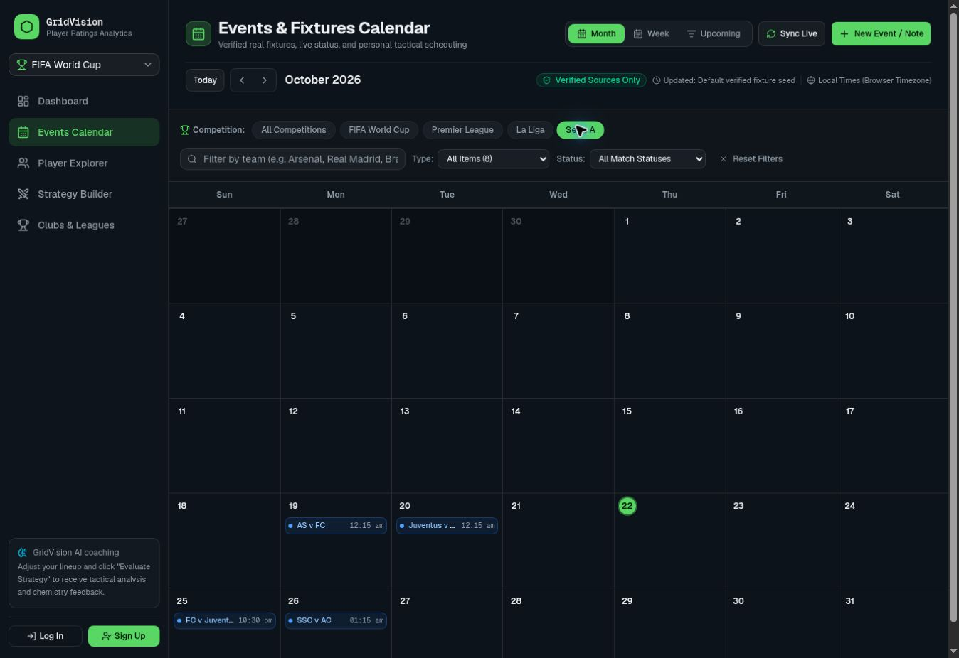
Figure 18 Serie A calendar filter at the original assessment
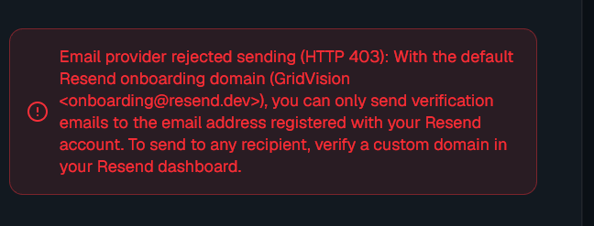
Figure 19 Historical email delivery configuration message

5.14 Defect Register and Readiness Assessment
Public browsing and selected local storage and calculation checks worked during the assessment. The team subsequently reported the calendar issue resolved. Remaining production checks concern authenticated workflows, durable storage, and the API findings in Table 25.
The next implementation cycle should address API access control, input handling, storage errors, and data labels. Calendar regression should confirm the reported correction against an identified release.
Ten original failures represent seven tested issue areas. D05 covers three calendar cases and is reported resolved by the team, leaving seven other failed cases across six tested issue areas unchanged. Historical results are preserved; the calendar correction is not counted as three independently verified passes. D08 and D09 retain their separate evidence classifications.
Table 25 Defect Register and Readiness Assessment
Defect | Severity | Evidence and disposition
D01 Strategy route lacks session guard | High | A14 source invocation HTTP 200; unresolved in supplied source
D02 Evaluation has no free-move coordinates | Medium | A12 generic Reasonable verdict; unresolved
D03 Quick Ask unsupported mode | Medium | A13 HTTP 400; unresolved
D04 Malformed JSON outside try | Medium | A15 uncaught parsing exception; unresolved
D05 Calendar coverage and Upcoming | Medium at baseline | TEAM1: reported resolved 23 Oct 2026; regression pending for B12 B15 A16
D06 Historical domestic data presented without date | Medium | B24 screenshot; unresolved
D07 Duplicate name and raw dropdown keys | Low | B03 B04; unresolved
D08 Delivery configuration | Operational validation | Historical HIST1–HIST2; fresh inbox test pending
D09 Local fallback and incomplete verification provenance | Medium source risk | SRC3 SRC4 SRC7; production impact unverified

6 Deployment Architecture and Release Requirements
The supplied Vercel HTTPS address was accessible during browser testing. The assessment checked public routes but did not inspect the hosting account, deployment pipeline, custom-domain settings, or infrastructure region.
The package defines dev, build, and start scripts. A release should install the project’s pinned package-manager version, restore dependencies from the lockfile, configure environment variables, initialise the PostgreSQL schema, run TypeScript and relevant tests, and build before deploying a preview. Production should follow only after preview acceptance.
Google Geist fonts are requested at build time through next/font/google. The local build attempt was blocked by unavailable external font retrieval. A network-enabled build environment or a deliberately reviewed self-hosted font change would resolve that prerequisite, but the source was not modified for this report.
The Django Elo URL is loopback and does not point to the developer’s computer from a Vercel function. A hosted engine would require an explicit remote URL and appropriate availability, timeout, and response validation. Until then, derived fallback ratings must be labelled honestly.
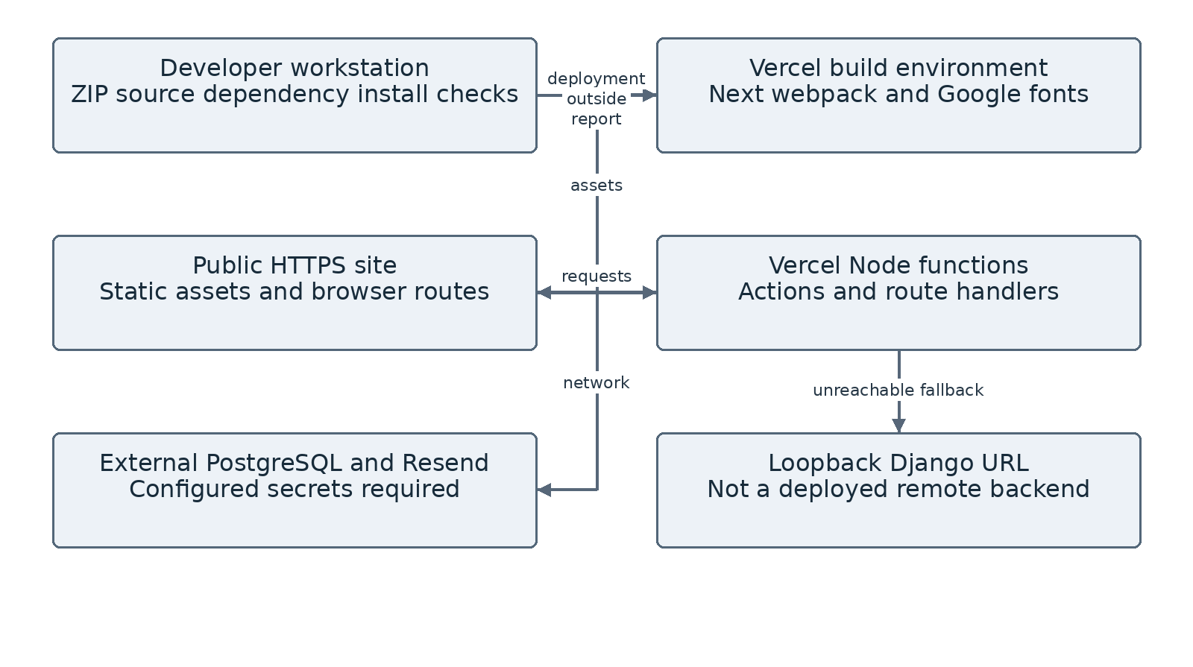
Figure 20 Deployment architecture

6.1 Configuration and Maintenance
Environment values belong in the deployment settings and must remain private. Table 26 lists the required variable names and their purposes. The assessment did not inspect their production values.
DATABASE_URL should select a durable PostgreSQL database with the required schema. AUTH_SECRET should be generated securely and required in production. NEXT_PUBLIC_APP_URL should contain the canonical public HTTPS origin used for email links. RESEND_API_KEY and EMAIL_FROM must belong to an authorised verified sender configuration.
Vercel’s documented function filesystem is read-only apart from temporary scratch space. The project’s .data fallback under the application working directory is therefore not a dependable production data store. Even temporary writable storage would not establish shared durable records. A production health check should fail clearly when the database is unavailable.
Maintenance should include database backups and restore drills, dependency review, token-log redaction, email bounce/delivery monitoring, fixture freshness checks, and periodic data-source and image-rights audits. Record a deployment identifier and dataset version with every release so future reports can establish source-to-live equivalence.
Schema changes need reviewed migrations rather than relying on the supplied persistence test to create tables. That test checks for required tables and expects initialisation to have happened already. It should run only against a designated nonproduction database with disposable records.
Table 26 Configuration and Maintenance
Variable | Purpose | Release verification
DATABASE_URL | PostgreSQL connection | Schema connectivity persistence owner tests
AUTH_SECRET | Session HMAC signing | Required strong secret without fallback
NEXT_PUBLIC_APP_URL | Absolute email callback origin | Matches deployed public HTTPS domain
RESEND_API_KEY | Server-side sending authorisation | Provider account and domain scope valid
EMAIL_FROM | Verification sender identity | Verified domain and arbitrary-recipient test

6.2 Security Controls and Gaps
The account code includes salted password hashing, random verification tokens, signed HTTP-only cookies, expiry checks, and a resend cooldown. Saved-strategy operations apply ownership checks, which passed in the local test branch.
The strategy API needs the same access policy as its protected page, or its public status needs to be documented. The tested handler generated feedback from submitted input; the assessment did not establish access to private stored records through this route.
Production hardening should remove the default signing secret, avoid logging full verification links, store token hashes where appropriate, invalidate superseded tokens intentionally, and apply abuse limits to signup and login as well as resend. The six-character minimum password rule is present in source; whether it meets the project’s policy requires an explicit security decision.
Database failures should not silently fall back to conflicting local identity or event stores. Input validation should check lineup length, duplicate players, allowed modes and formations, coordinate bounds, event dates, title length, and share-recipient permissions on the server. The inspected route uses TypeScript casts, which are not runtime validation.
Security review was limited to source inspection and bounded local tests. Intrusion attempts, credential attacks, load tests, and production cross-user mutations were not performed.
Table 27 Security Controls and Gaps
Area | Existing control | Recommended next verification
Session | HMAC signature expiry secure cookie | Strong secret and forged/expired token tests
Ownership | Session-derived strategy user ID | Two-account production action tests
Verification | Random one-hour used-token deletion | Inbox expiry replay and superseded-token tests
Privacy | Server-side email API key | Remove token and recipient logging
Validation | Selected form and name checks | Complete runtime schema and negative cases

6.3 Limitations and Practical Improvement Plan
The main testing limitation was access to protected workflows and controlled infrastructure. A designated account and an isolated database are needed to check browser restoration and sharing. The original browser assessment used one desktop engine, so mobile and cross-browser results remain incomplete.
The analytical method is also limited. Tactical feedback uses thresholds and templates, while free-move coordinates are not evaluated. Forecast calibration and independent tactical validation were outside the completed tests.
Data-quality work remains necessary for historical club associations, partly derived World Cup attributes, and player-image provenance. Dated records and documented image permissions would improve traceability. The calendar correction is recorded separately as resolved by the team, pending independent regression.
The next cycle should validate protected workflows and durable storage, align tactical evaluation with pitch coordinates, improve player-data provenance, and complete responsive and two-account tests. Calendar regression should confirm the reported correction. Model-backed assistance can then be evaluated against cost and answer-quality criteria.
Future additions should follow the existing planning focus. Video recognition and automatic annotation would require new data, processing services, permissions, and tests. They remain proposed features.
Table 28 Limitations and Practical Improvement Plan
Priority | Concrete outcome | Acceptance test
First | Verification and durable personal records | C03 C05–C10 C13 C14
Regression | Confirm reported calendar correction | B12 B15 A16 C11 C12 C17
Next | Meaningful explicit tactical evaluation | A12 A13 A14 C01 C02
Then | Reliable identity and mobile usability | C15 C16 C19 C20

6.4 Conclusion and Demonstration Checklist
GridVision combines player exploration, team comparison, tactical arrangement, and event planning in one application. The project connects reusable interface components with server actions, data modules, and personal storage. The diagrams and implementation chapters explain these relationships.
The assessment confirmed public navigation, search, sampled player pages, competition filtering, and squad-style explanations. Local saved-strategy tests preserved coordinates and enforced ownership. The team has reported the calendar issue resolved; independent regression remains pending.
The baseline remains 32 Pass, 10 Fail, 17 Blocked, and four Not Run across 63 cases. Three calendar failures are linked to the reported correction and await regression evidence. The other seven failures concern display labels, historical-data presentation, unsupported Quick Ask, spatial feedback, API authentication, and malformed-input handling.
A project demonstration should use the current dataset, identify the rules-based feedback method, and connect each feature to its test evidence. A designated account and disposable records are needed to demonstrate protected workflows.
The current result is a partially working integrated prototype. Public exploration and selected local functions have been demonstrated.

Table 29 Conclusion and Demonstration Checklist
Before demonstration | Completion evidence
Confirm student and institution details | Authorised review and signatures
Record deployment and dataset versions | Release metadata and source hash
Complete protected-workflow checks | Fresh service and persistence evidence
Retest listed defects | Updated case results and screenshots
Keep claims within evidence | Clear current historical and proposed labels

